Name

7th Grade Language Arts Distance Learning Assignment
Week 4

A Note to Parents
This week, your student should read "Mother to Son" by Langston Hughes.
(https://www.commonlit.org/en/texts/mother-to-son) In this poem, a mother utilizes metaphor to communicate the struggles she's faced and the importance of perseverance to her son.
Consider discussing the themes of Friendship & Family and Resilience & Success as they relate to the text. These big questions can help drive discussion: "How does a person overcome adversity?" and "What can you learn from family?"
Ways to support your child:
- Ask your child about this poem:
- What was "Mother to Son" About
- What did you learn about? About Resilience & Success?
- Watch the following clips with your child at home:
- 'The Harlem Renaissance' (https://www.youtube.com/watch?v=GfcO2HKyPVE)
- 'Langston Hughes - Biography' (https://www.youtube.com/watch?v=inP76rkYUso)

Day 1, Activity 1: Vocabulary Review
Step 1: Review the below vocabulary words by revisiting your work from weeks 1-3.
Step 2: Write a short response journal discussing how to approach a difficult challenge.
Step 3: Include in your journal at least five of the below vocabulary words, used correctly. You may have to change the form of the word (ex: go, going, gone).
Accuse |  | Allow |  | Coordinate |  | Doubt |  | Impostor
Interrogate |  | Mock |  | Rigid |  | Sprawl

Day 2, Activity 1: Your Opinion
“The American Dream” is the belief that anyone, regardless of their background, can become successful and happy in this country. In your opinion, do all Americans have equal access to the American Dream? What are some factors that could make it easier or harder to achieve happiness?

Day 2, Activity 2: Reading a Poem
Use the following steps to read and interpret the poem.
- Read the poem all the way through, at LEAST twice. *At the end of the poem, write your first impressions or immediate thoughts—positive or negative.
- Determine who the speaker of the poem is. You don’t have to name the speaker, just find out what you can about him/her/it. *Highlight and annotate any details in the poem that give away any information about the speaker.
- What is the subject of the poem? What does the speaker think or feel about the subject? *Write a short sentence answering these two questions under your first impressions.

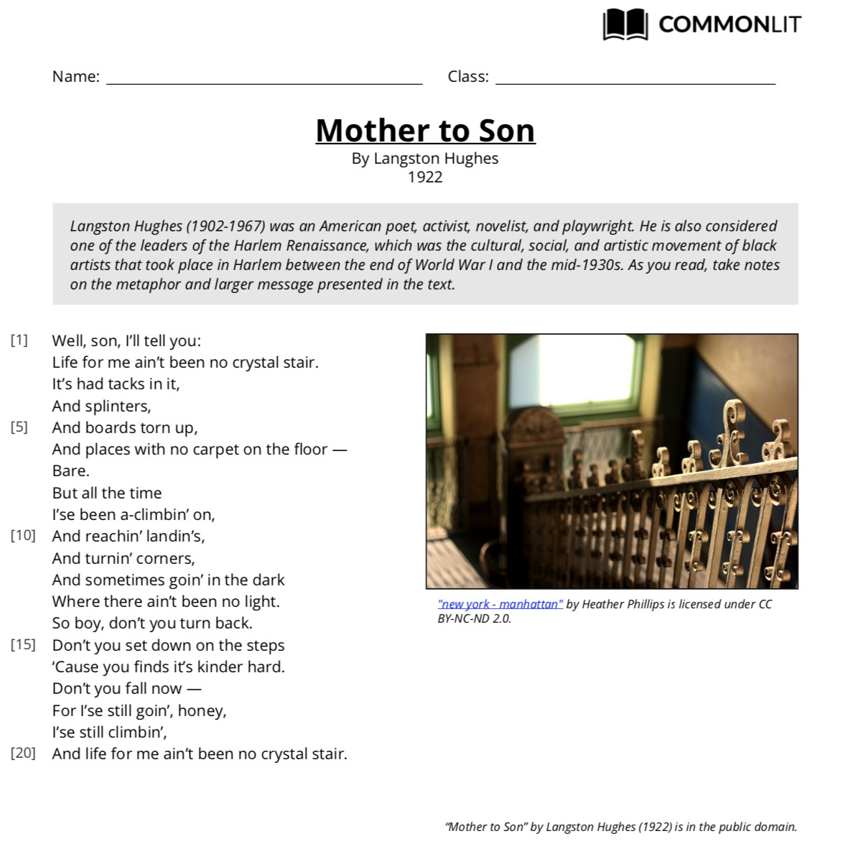

Day 3: Conversation with the Speaker
Look back at your opinion regarding whether all people have equal access to the American Dream. How is your opinion different and/or similar to the speaker’s opinion? Why do you think the speaker feels the way she does?

Complete the following Text-Dependent Questions for Day 4.

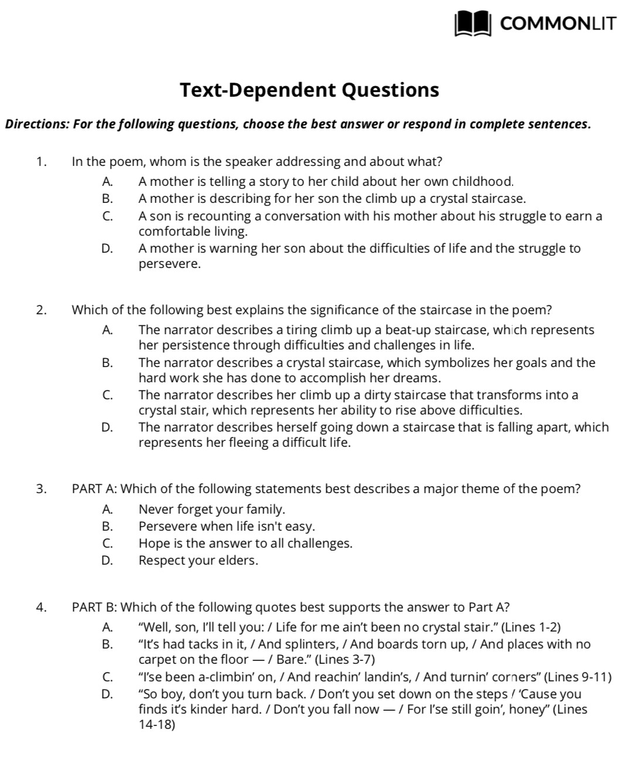

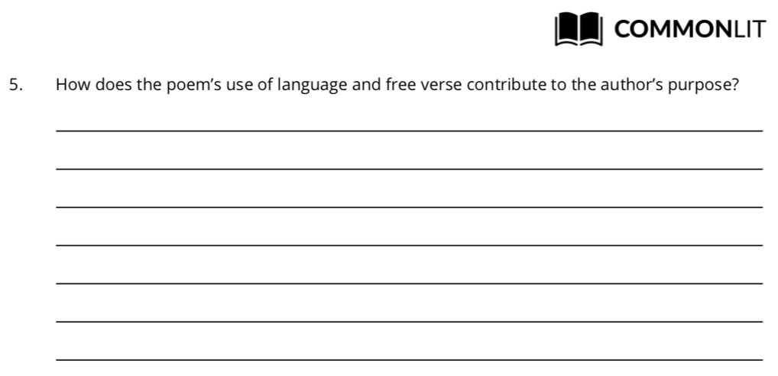

Day 4: Your Life Advice
In Langston Hughes’ poem, the mother gives her son life advice through the extended metaphor of life being a set of stairs. Think about someone you care about—a sibling, a friend, or a younger family member—and think about a piece of advice you would give him or her. Is it about life? Love? School? Now, think about what you could compare that concept to in an extended metaphor.

Using your thoughts as inspiration, use Langston Hughes’ poem as a model to write your own poem. Some words have been included in the lines below for guidance, but if they don’t work, you may cross them out. Be authentic. “Mother to Son” was written in a working class, black vernacular of the 1930s. Write your poem in your own voice.

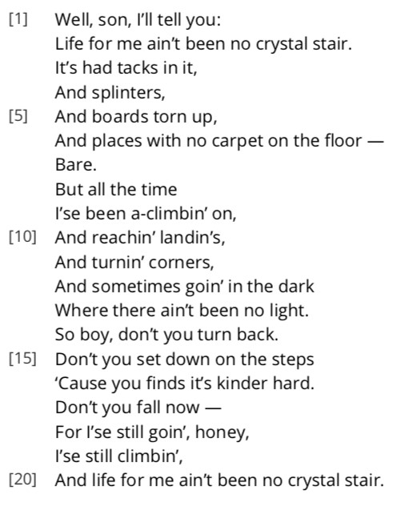
Well, , I’ll tell you:

It’s
And
And
And

But all the time
I
And
And
And

So, , don’t
Don’t
Because
Don’t
Because I
And
(repetition of 2nd line)

Day 5: Learning from What You’ve Read
Think back on the texts you’ve read the past four weeks: Norma Fox Mazer’s short story, “Tuesday of the Other June,” Rudyard Kipling’s poem “If,” “What My Father Said” by Alan King, and this week’s poem. Each of these has dealt with overcoming obstacles and parents’ advice. What lessons do these texts offer regarding overcoming obstacles or following a parent’s advice? Write an extended response answer to this question using one quote from at least two different texts as support for your answer.

