Name

7th Grade Language Arts Distance Learning Assignment
Week 3

A Note to Parents
This week, your student will read another poem titled "What My Father Said" by Alan King .
(https://www.commonlit.org/en/texts/what-my-father-said) In this poem, a boy wants to play with his friends but his father puts him to work.
This text relates to the themes of Friendship & Family and Social Pressure. Consider discussing with your child the following questions: "What are the effects of following the crowd?" and "What makes a family?"
Ways to support your child:
- Ask your child about this poem at home:
- What was "What My Father Said" About
- What did you learn about? About Social Pressure?
- Watch the following clips with your child at home:
- 'Tips for Dealing with Disappointment ' (https://www.youtube.com/watch?v=2vcvFPtG4No)
- 'Why I listen to my parents(more)' (https://www.youtube.com/watch?v=AlBY9NjhdJM)

Day 1, Activity 1: Vocabulary in Context
Step 1: Review the vocabulary word, context sentence, picture, and definition.
Step 2: Describe how the context sentence and photograph give hints toward the meaning of the word. Be specific; you must include either specific words from the context sentence or details from the photograph in your answer.

1. Coordinate
I have horrible hand-eye coordination; I’ve never been able to catch a football or throw something to hit a target.
Definition: to arrange, select, or organize things so that they work well together toward a common goal
Explanation of Context:

1 Some think that this Japanese couple are peak
relationship goals. Married for 37 years, they
always wear coordinating outfits.

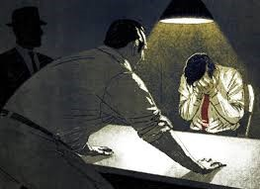
2. Interrogate
Mom’s interrogative tone made me think she didn’t believe me when I said I stayed after school to study.
Definition: to question for a long time for an official purpose
Explanation of Context:

2 The police interrogated the suspect about where
he was at the time of the crime.

3. Accuse
The teacher accused the girl of cheating on the test.
Definition: to say that someone has done something wrong or illegal
Explanation of Context:

3 Sam was tired of his girlfriend’s constant accusations.

Day 1, Activity 2: Journal Response
Discuss a time when you disagreed with a decision your parents, teacher, or another adult made that ended up being correct. How did you feel then? How do you feel about the decision today?

Day 2: Active Reading
Today, you are reading another poem. Use the following steps excerpted from Teach For America to read and analyze this poem.
- Read the poem all the way through, at LEAST twice. *At the end of the poem, write your first impressions or immediate thoughts—positive or negative.
- Determine who the speaker of the poem is. *Annotate any lines that give this away in the passage with your thoughts.
- Go through the poem again line-by-line and translate or paraphrase what the speaker is saying in “real talk.” *Jot notes in the margins.
- Get to the core of what the poem is about by identifying its theme. The theme of the poem relates to a universal truth or issue. Consider the following questions when thinking about the theme: a. What is the subject?
  - What does the speaker feel about the subject?
  - What is the mood of the poem?
*Write a sentence about the theme somewhere toward the end of the poem.

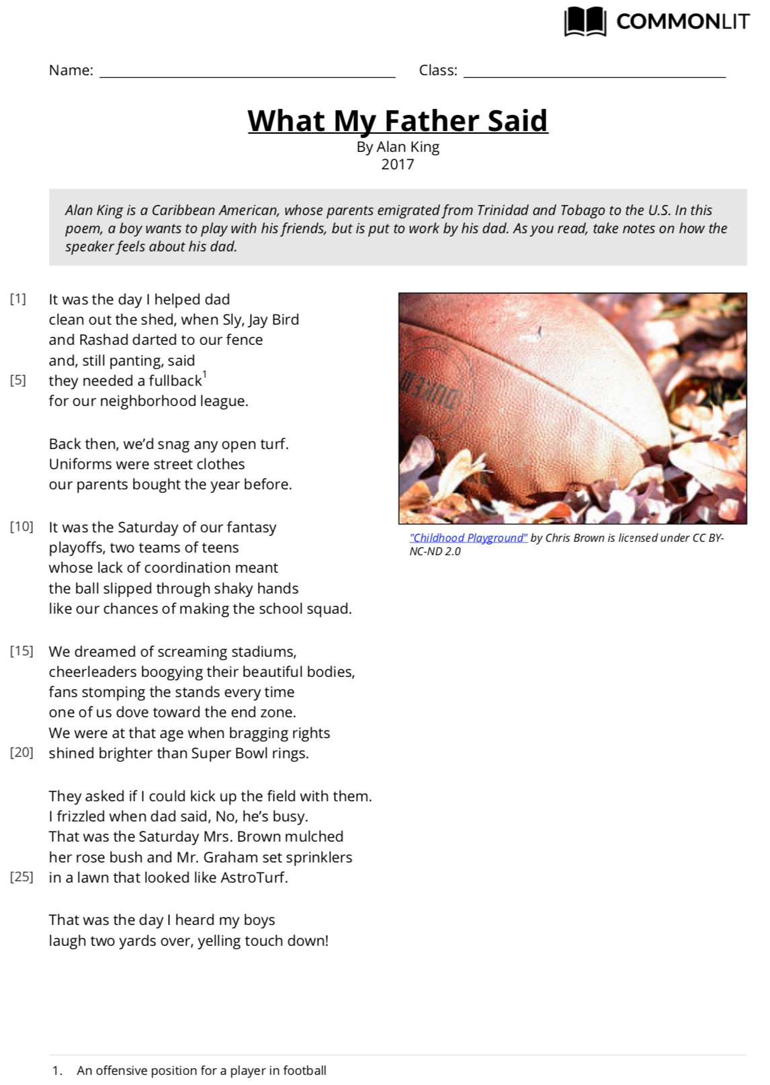
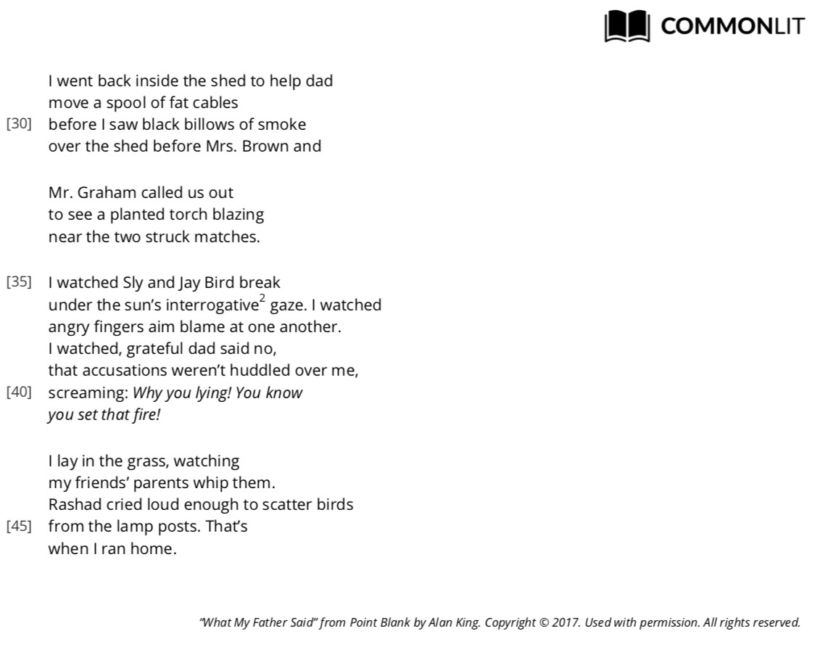

Day 3, Activity 1: Vocabulary Practice
Step 1: Fill in the blanks using the correct vocabulary word to complete each scenario. You may have to change the form of the word (ex: go, going, gone).
Step 2: Explain why the vocabulary word best fits based on context clues provided in the scenario.
Example: Every single day, Bryan wakes up at 5 o’clock in the morning to take a 10-mile jog. Then, he goes to the gym to lift weights. Afterwards, he does 20 laps in the pool. And this is before he goes to practice with the team every afternoon!
Bryan is relentless about training because he is extremely dedicated and exercises all of the time.
Coordinate Interrogate Accuse
- When Grayson was shopping in the store, the store keeper confronted him telling him he had shoplifted a candy bar. It wasn’t until Grayson showed the shopkeeper his empty pockets did he get a chance to leave the store.
Grayson was falsely because

- When Brittany showed up to pick up her date, her date’s dad asked her a million questions about her driver’s license, her grades in school, and what they were planning to do on the date.
Brittany was because

- To complete the group project, Jayden had to call the other group members, make sure they all knew which parts to do, collect the individual parts of the assignment from the group members, and put them together in a way that made the whole project look whole.
Jayden had to because

Day 3, Activity 2: Shift
A lot of poetry has a shift where either the circumstances or the speaker’s feelings change. A shift happens in this poem around line 30. Complete the graphic organizer below to demonstrate your understanding of what shifted in this particular poem.
The Speaker’s Feelings/Thoughts The Event that Changed the at the Beginning of the Poem Speaker’s Feelings |  |  | The Speaker’s Feelings/Thoughts at the End of the Poem
Description/Explanation

Lines from Poem to Support

Complete the following Text-Dependent Questions for Day 4, Activity 1.

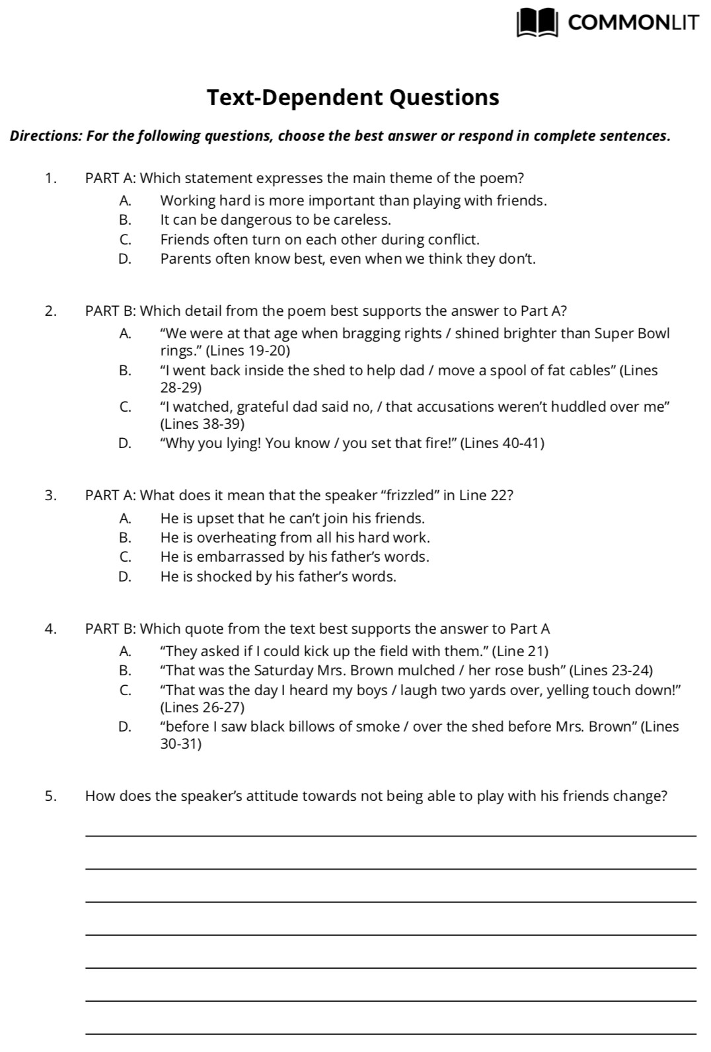

Day 4, Activity 2: Application of Vocabulary
Answer each question in 1-2 complete sentences. Make sure that you use the underlined vocabulary word in your answer.
- How would you coordinate with other friends to throw a surprise party for a friend?

- What are some strategies for staying cool during an interrogation by your parents or teacher?

- Why is it important to know all the facts before you accuse someone of a crime?

Day 5, Activity 1: What My Father Said on IG
Use the template below to create an Instagram profile and post for the speaker of the poem “What My Father Said.” Be sure to capture the essence of the speaker of the poem at the time of his post and his feelings at the conclusion of the poem. Include an appropriate handle (or username), picture, caption, and clever hashtags.
