Language Arts

Grade 7 / Week 6

Standards Covered this Week
- LAFS.7.RL.1.2: Determine a theme or central idea of a text and analyze its development over the course of the text; provide an objective summary of the text.
- LAFS.7.RL.2.4: Determine the meaning of words and phrases as they are used in a text, including figurative and connotative meanings, analyze the impact of rhymes and other repetitions of sounds (e.g., alliteration) on a specific verse or stanza of a poem or section of a story or drama.
- LAFS.7.W.3.9: Draw evidence from literary or informational texts to support analysis, reflection, and research.

Name

Teacher

A Note to Parents
Continuing the “New Perspectives” thematic unit, your student will read and analyze Paul Laurence Dunbar’s poem, “We Wear the Mask” this week. Due to this extremely sensitive time, it is understandable if students first think of the medical face masks many of us are wearing in public places. However, Paul Laurence Dunbar’s poem refers to metaphorical masks—strategies we use to hide our true selves from the public. Due to its popularity as a poem to teach in language arts class, there are many resources online that you can find to assist your child in the understanding of this poem.

Here are some optional online resources to support or extend your student’s thinking:
- This text is also available through CommonLit, which provides an audio read-aloud, translation, and online annotation features. Students should access CommonLit through their ClassLink. https://www.commonlit.org/en/texts/fyc-we-wear-the-mask
- Watch a dramatic performance of “We Wear the Mask” https://youtu.be/jDwgnWE6jW8
- Watch Maya Angelou in a powerful, emotionally moving presentation of her combination of Dunbar’s poem with her own https://youtu.be/_HLol9InMlc

Day 1, Activity 1: Quick Write
Think about a time when you have pretended to be something that you aren’t or when you have hidden your true
feelings. Why did you choose to hide yourself or your feelings?

This week, you’ll be reading a poem about hiding one’s true self from the world. Keep in mind the many reasons why people would need to or want to do this.

Day 1, Activity 2: Skills Focus
Mini Lesson: Quoting Evidence from Poetry
- We use direct evidence from the text in our writing:
  - To support our ideas or answer a question with specific examples
  - To think more deeply about the text we are reading
  - To help us explain our thinking
- In previous units, you’ve learned how to quote evidence correctly from fiction or nonfiction.
- Here’s how to quote evidence from poetry correctly
  - Signify a line break with a /
  - Signify a stanza break with a //
  - Add quotation marks around the quote: “Words from poem”
  - Cite line numbers. In addition, cite the poet’s last name the first time the poem is quoted: (Williams, lines 5-8)
Just to Clarify:
Lines of a Poem | “Afton Water” by Robert Burns  [9] How lofty, sweet Afton, thy neighbouring hills,  [10] Far mark'd with the courses of clear winding rills;  [11] There daily I wander as noon rises high,  [12] My flocks and my Mary's sweet cot in my eye.  [13] How pleasant thy banks and green valleys below,  [14] Where wild in the woodlands the primroses blow;  [15] There oft, as mild Ev'ning sweeps over the lea,  [16] The sweet-scented birk shades my Mary and me. | Stanzas of a poem

Sample Paragraph:  The speaker sees beautiful things along the Afton. He says, “There daily I wander as noon rises high, / My flocks and my Mary’s sweet cot in my eye. // How pleasant thy banks and green valleys below” (Burns, lines 11-13). | Notice How I:  - Signify a line break with a /  - Signify a stanza break with a //  - Add quotation marks around each quote  - Cite the line numbers  - Cite the author’s last name, since this is the first time the poem is quoted in the paragraph
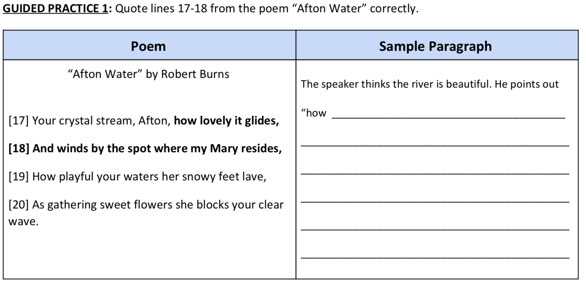
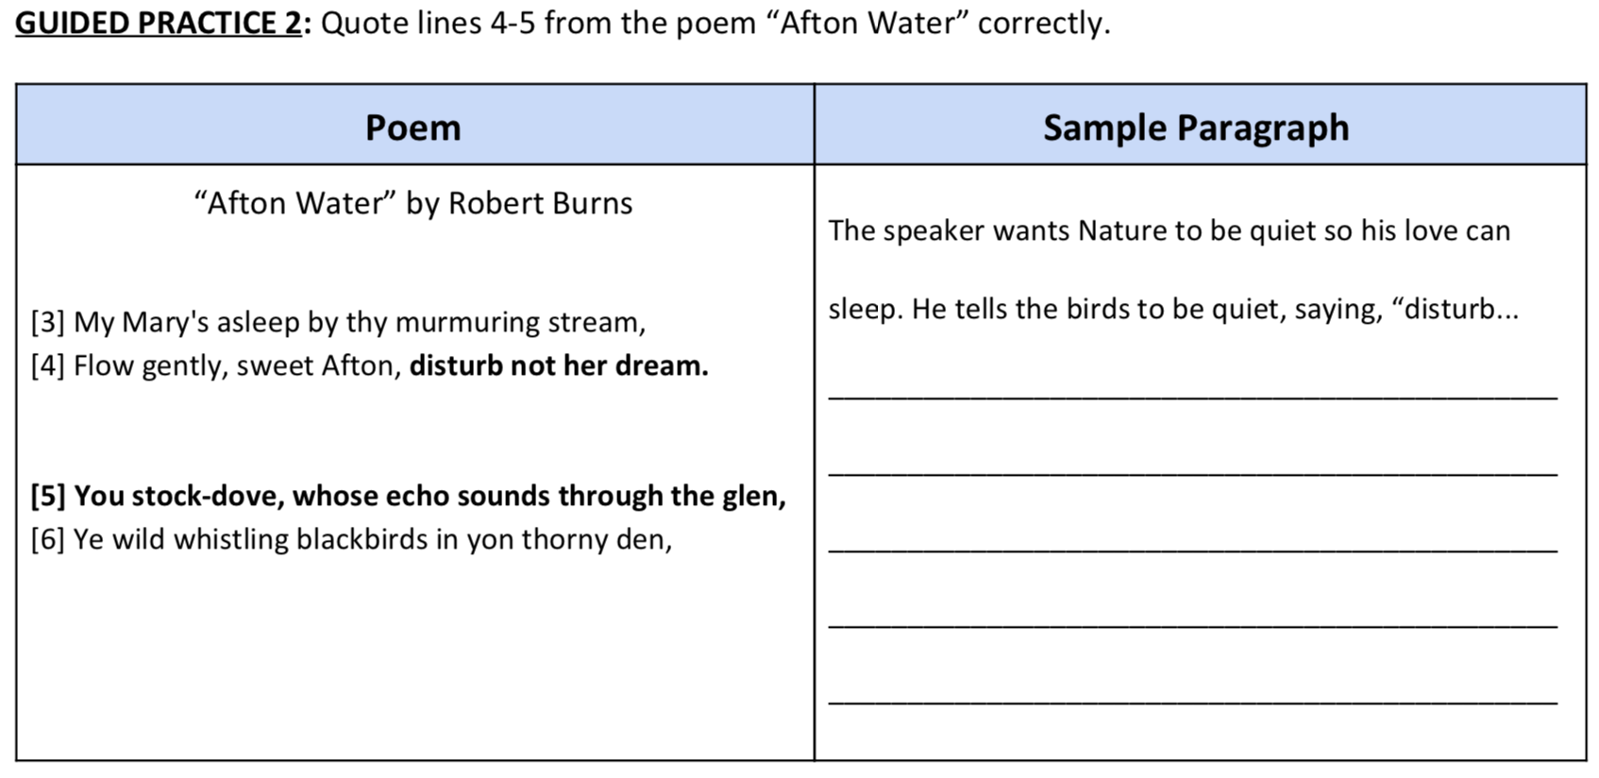
Now you’ve learned how to quote poetry correctly, you’ll use these skills when you analyze figurative language in the next lesson!
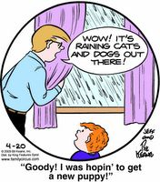
Day 2, Activity 1: Skills Focus
Mini Lesson: Analyzing Figurative Language
Figurative language describes one thing by comparing it to another. Like in this example, figurative language is often not literally true. No, it is not actually pouring puppies and kittens from the sky!

All writers use figurative language to make their descriptions come alive. However, poets tend to use it most often. Understanding how to analyze and write about figurative language will make you a better thinker and reader.

In order to fully analyze a quotation with figurative language, we follow the steps below:
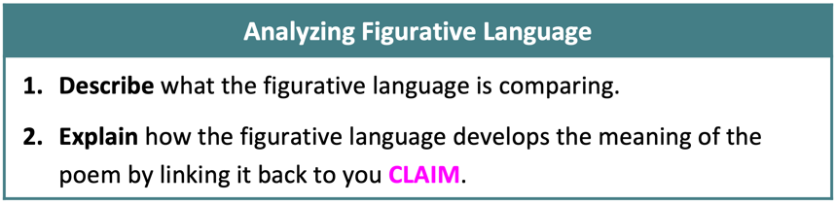

Take a moment to read “A Red, Red Rose” by Robert Burns

A Red, Red Rose
[1] O my Love is like a red, red rose
[2] That’s newly sprung in June;
[3] O my Love is like the melody
[4] That’s sweetly played in tune.

[5] So fair are you, my pretty girl,
[6] So deep in love am I;
[7] And I will love thee still, my dear,
[8] Till all the seas go dry.

[9] And fare thee well, my only love!
[10] And fare thee well awhile!
[11] And I will come again, my love,
[12] Though it were ten thousand mile.

MY ACTION STEPS:
- I get what this poem is about. (The poet really loves someone.)
- I find a piece of figurative language I want to talk about. (lines 1 & 2)
- Now, to analyze the figurative language, I need to:
  - Describe what is being compared. (The speaker compares their beloved to a red flower.)
  - Explain how it develops the meaning of the poem. (The color red represents love and romance. By comparing the beloved to a “red, red rose,” the poet shows the strength of his love for her.)
Now you take the next two lines:
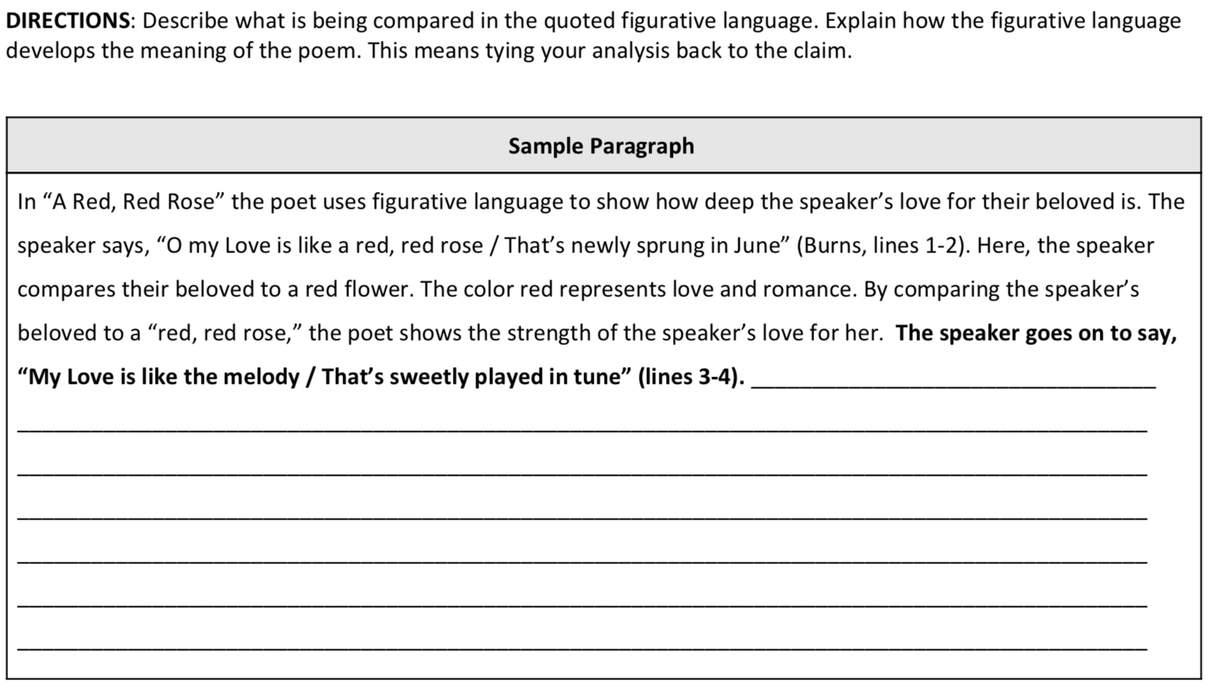

Day 2, Activity 2: Brainstorm
The subject of wearing masks has never before been so popular than it is right now in the time of the Coronavirus. However, masks come in all different shapes and sizes, for many different purposes, and are worn for so many different reasons. In the space below, brainstorm all of the reasons you can think that people wear masks.

Day 3: Active Reading
We Wear the Mask
Paul Laurence Dunbar
About this Text: Paul Laurence Dunbar (1872-1906) was one of the first African American Authors to reach a national and international audience. Best known as a poet, Dunbar published his first poems at age 16.

Skills Focus
In this lesson, you will analyze how the author uses word choice and figurative language to develop the meaning of a poem.
How do we analyze word choice and figurative language?
In order to analyze the effect of word choice and figurative language, we pay special attention to the descriptive words and phrases in a poem. We also notice the figurative language, especially similes and metaphors. Then, we determine what these words and phrases suggest about the speaker or topic of the poem and how they contribute to the author’s message.
FIRST READ: Read aloud without stopping all the way through once. | SECOND READ: Read the poem again, stopping to consider the questions below as you encounter them.
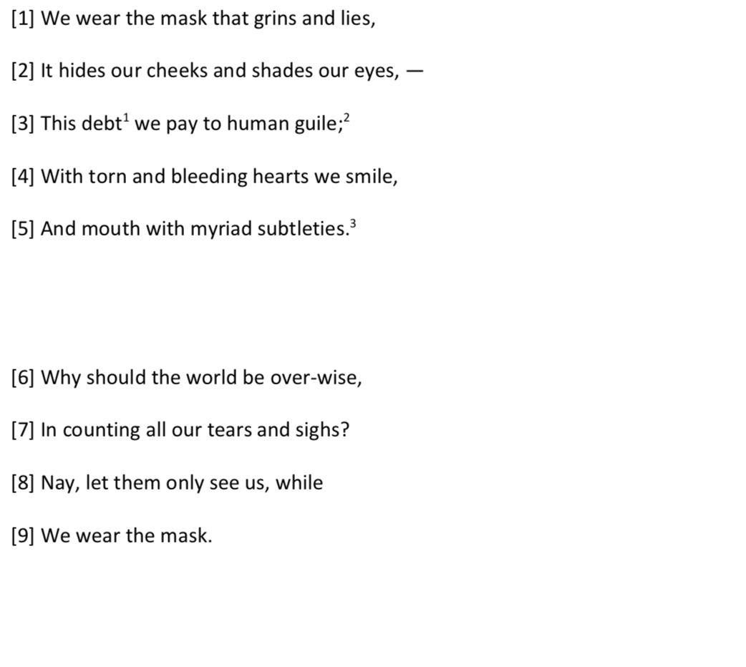  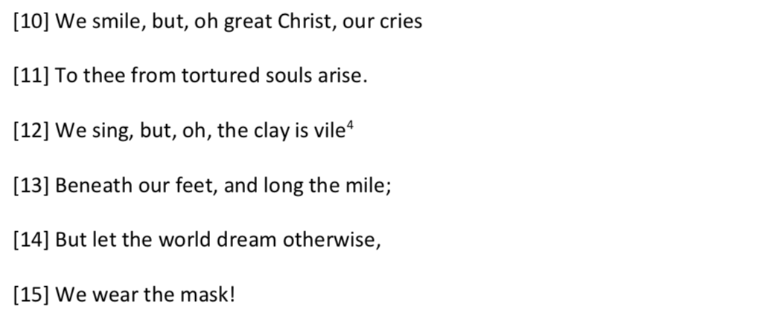 | Lines 1-5  - What does the mask look like?  - Find Evidence: Underline a detail that shows how the people behind the masks feel.  - Why does the speaker say the mask lies?  Lines 6-9  What are the people hiding behind the mask?  Lines 10-15  - Lines 10-11 are split by the word “but.” How is the part before the word “but” different emotionally from the part after?  - How are lines 12-13 similar to lines 10-11?  - Why do the people “smile” and “sing”?
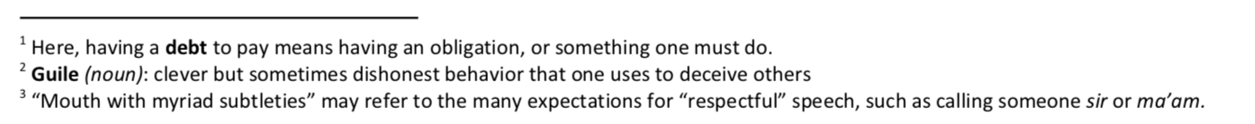
AFTER THE FIRST READ: What is the main idea or “gist” of this poem?

THIRD READ: Use the questions below to return to the poem and consider the text again.
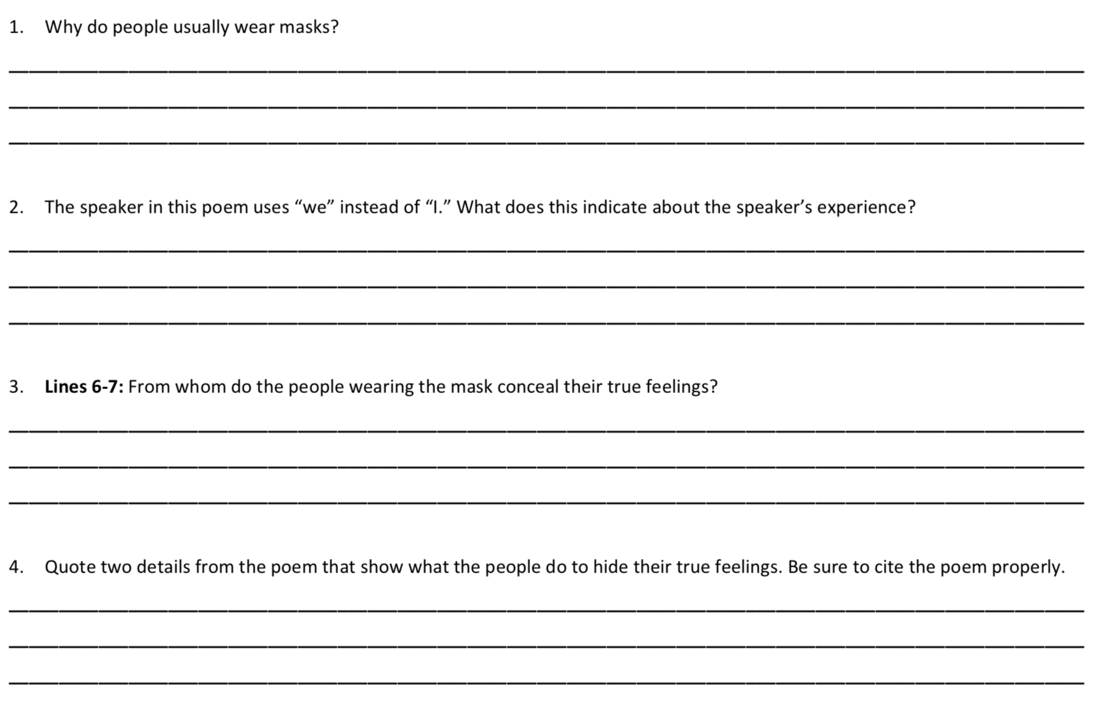
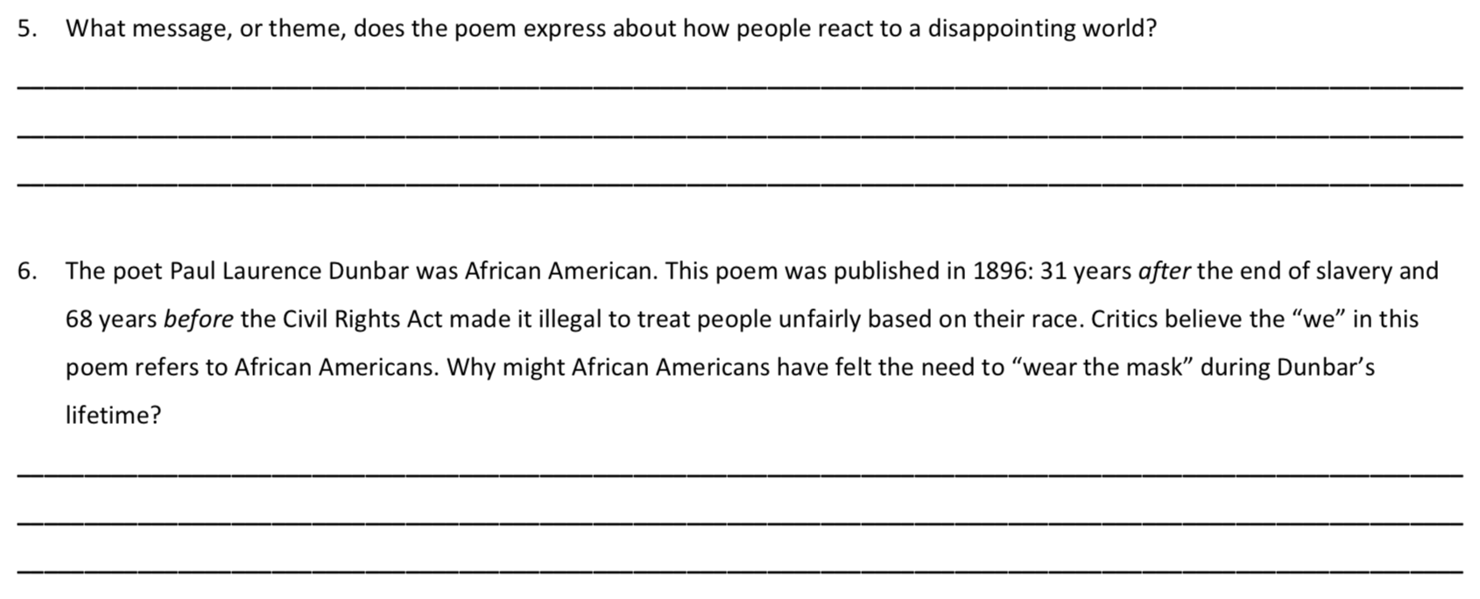

Day 4: Text-Dependent Questions
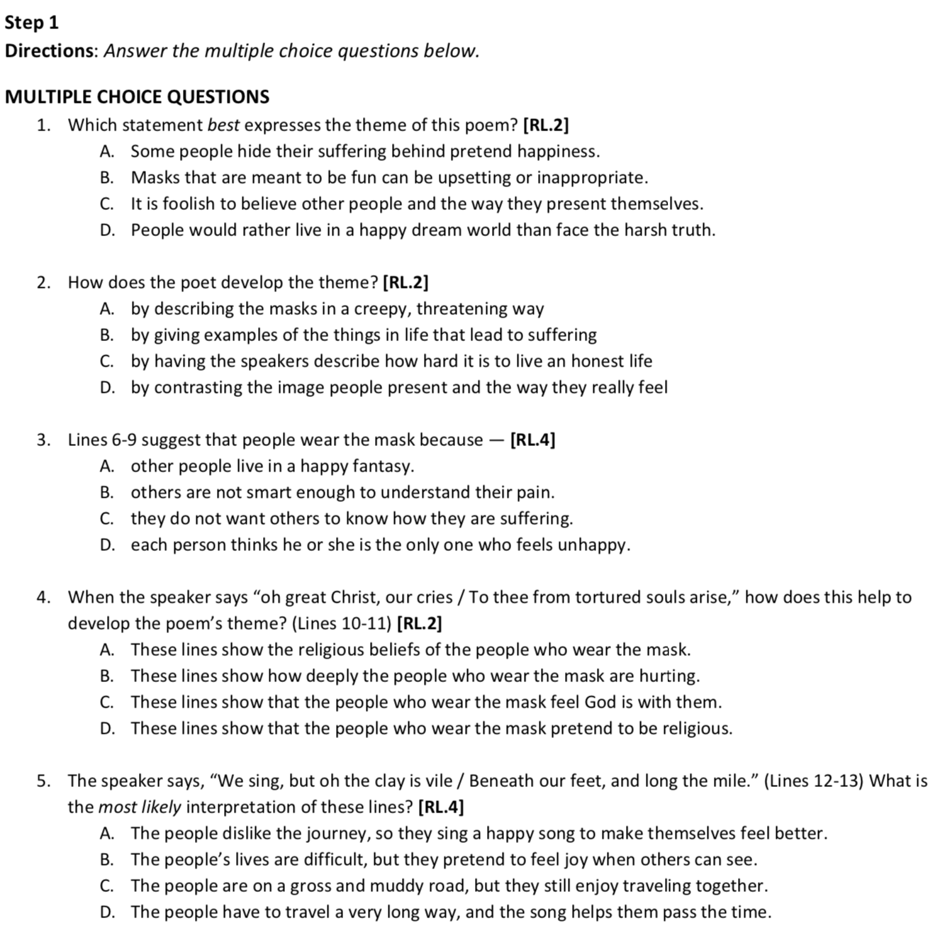

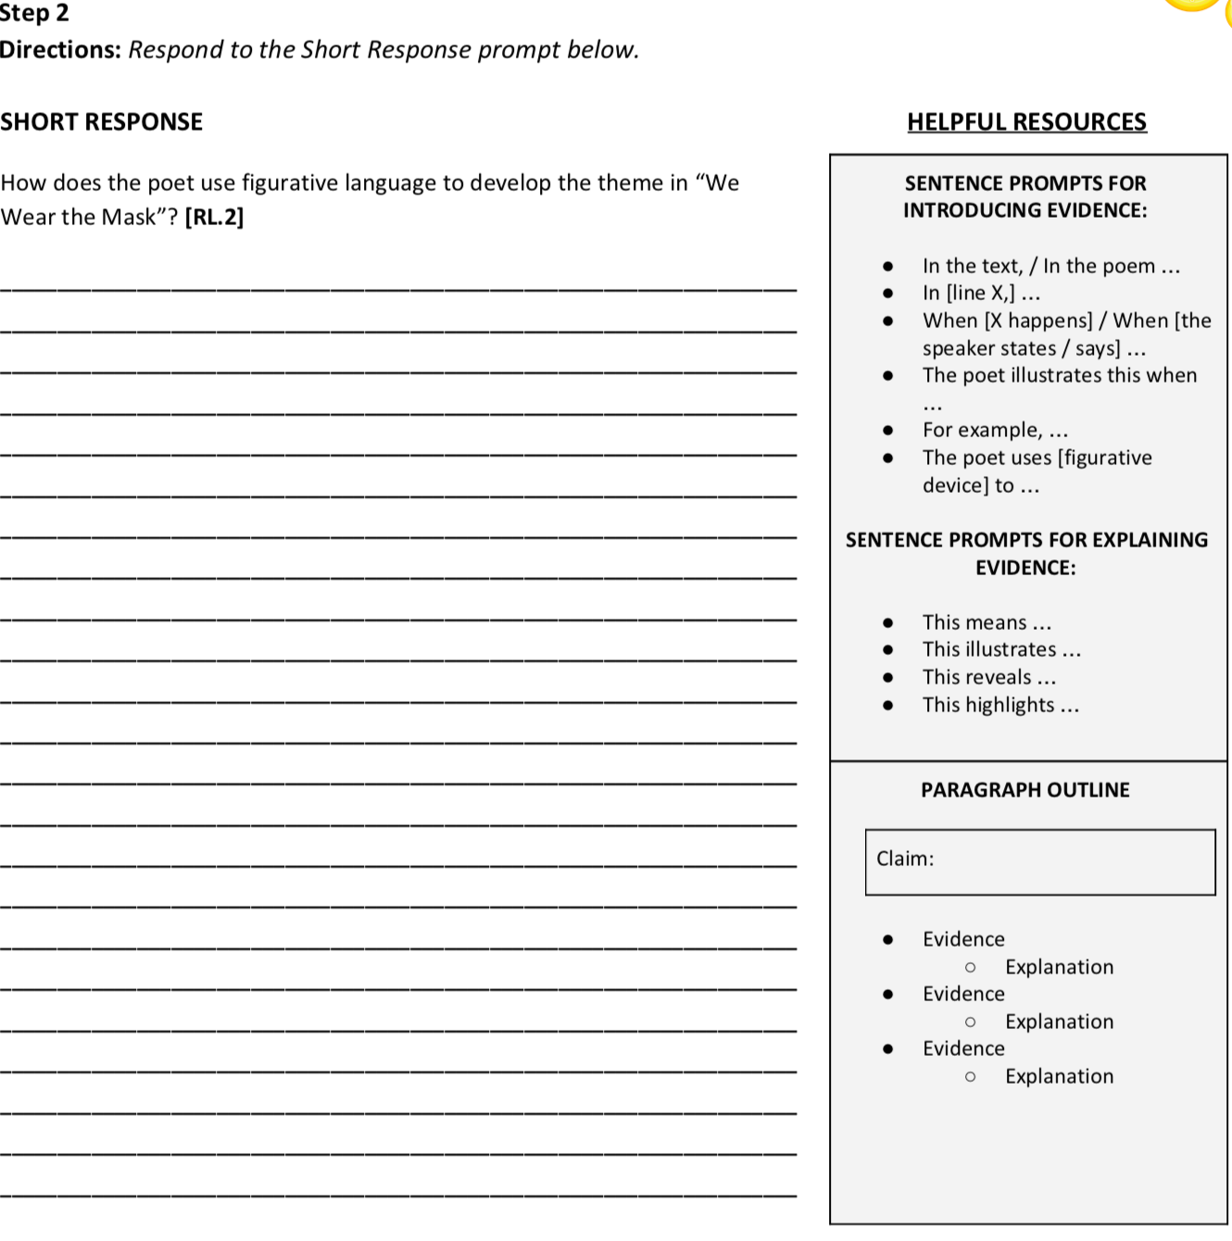

Day 5: Your Personal Mask
The following assignment is intended to prepare students for creating their own personal identity masks that answer the question, “Who am I?” Creating the actual mask is optional (if you do, please consider sending a picture of your mask to your teacher!). However, respond to the questions below as if you were brainstorming what would go on a mask that represents you.
