Language Arts

Grade 7 / Week 5

Standards Covered this Week
- LAFS.7.L.3.4.a: Determine or clarify the meaning of unknown and multiple-meaning words and phrases based on grade 7 reading and content, by using context (e.g., the overall meaning of a sentence or paragraph; a word’s position or function in a sentence) as a clue to the meaning of a word or phrase.
- LAFS.7.L.3.4.d: Verify the preliminary determination of the meaning of a word or phrase (e.g., by checking the inferred meaning in context or in a dictionary).
- LAFS.7.RL.2.6: Analyze how an author develops and contrasts the points of view of different characters or narrators in a text.

Name

Teacher

A Note to Parents
For the next five weeks, your student will be working through a unit entitled “New Perspectives,” which will include texts that explore characters who are gaining new understandings about themselves or their world. Your student will be focusing on point of view—how a person’s point of view can affect their choices and behavior and how authors develop and reveal differences in characters’ or narrators’ points of view in their writing. As your student works through the unit, consider discussing with him or her the following question: How can a disappointing world impact our perspective? Can there be positive consequences of this change in perspective as well as negative? This week, your student will read a short story called “Sol Painting, Inc.” by Meg Medina.

Here are some optional online resources to support or extend your student’s thinking:
- This text is also available through CommonLit, which provides an audio read-aloud, translation, and online annotation features. Students should access CommonLit through their ClassLink. https://www.commonlit.org/en/texts/fyc-sol-painting-inc
- Access an audio version of the text from Penguin Random House Audio here: https://soundcloud.com/penguin-audio/flying-lessons-other-stories-sol-painting-inc-written-and-read-by-meg-medina
- Learn more about the author here: https://megmedina.com/

Day 1, Activity 1: Introduction to Vocabulary
Step 1: Based on the context sentence and the photo, write down your best prediction for the definition of each word. The first one is done for you.
- Apprentice
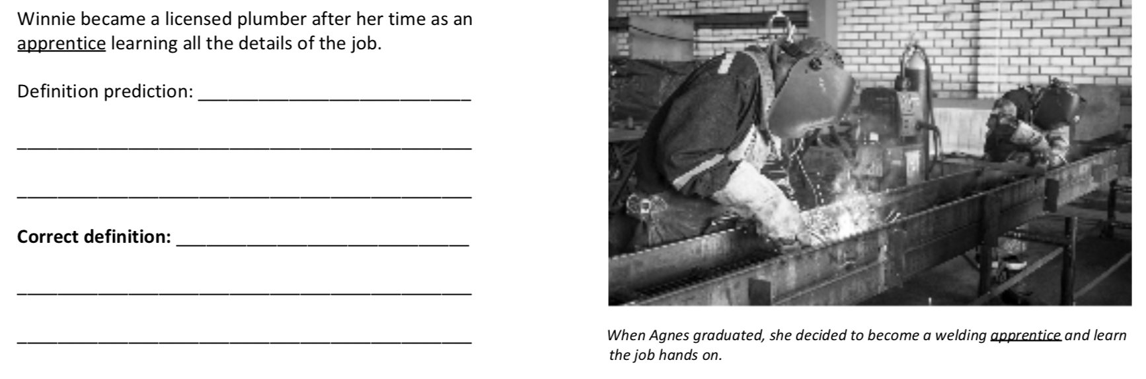
Student
- Enforce
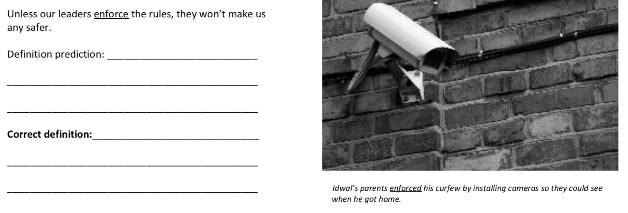
- Gape
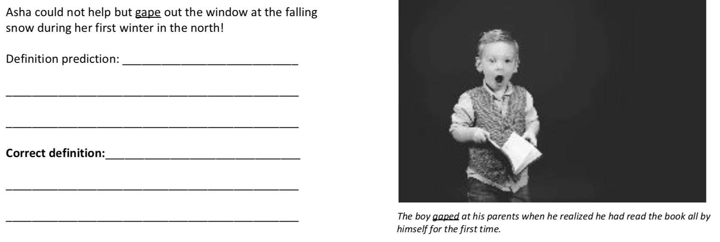

- Maneuver
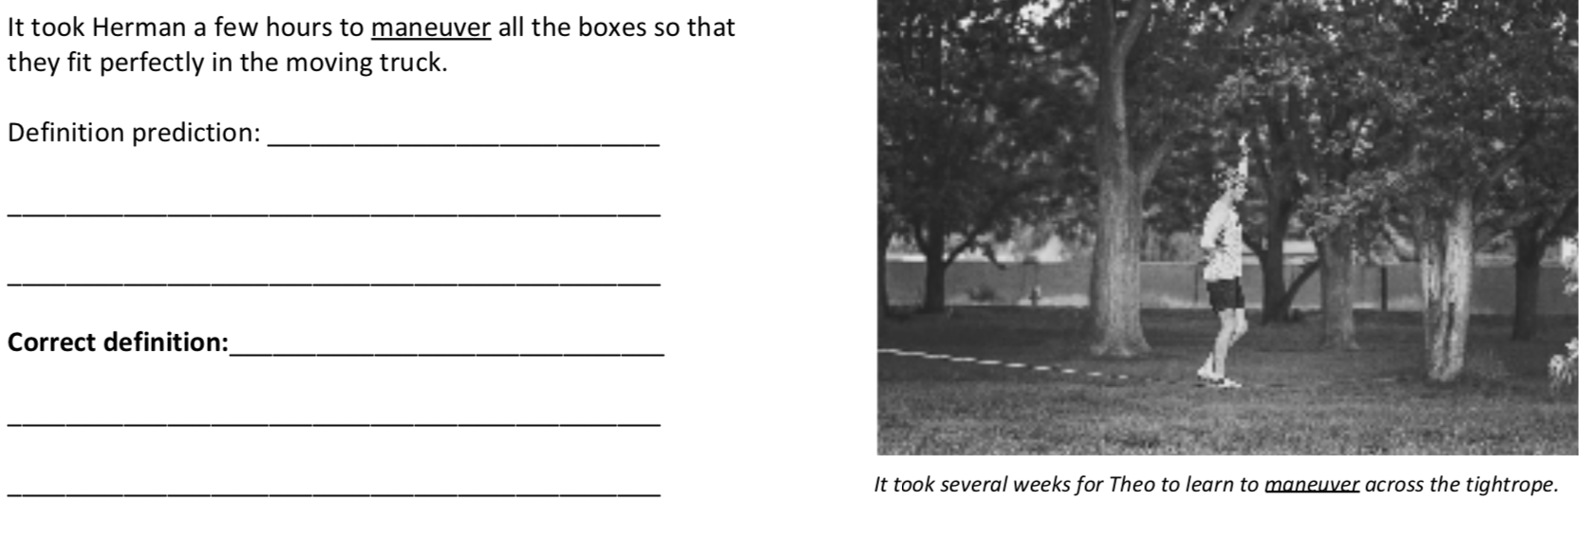
- Manicure
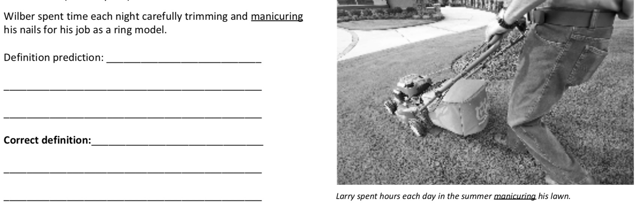
Step 2: The below definitions are written in the order of the vocabulary above. Copy the correct definition for each word onto the lines in your packet. How close were your predictions?
- A person who works for another in order to learn a skill
- To make people follow or obey a rule or law
- To stare with one’s mouth open in surprise
- To move skillfully or carefully
- To trim or cut with extreme care; to groom

Day 1, Activity 2: Quick Write
The texts we will read in this unit will explore characters who are gaining new understandings about themselves or their world. Sometimes these new understandings are unexpected or even disappointing. Think of a time growing up that you learned something about the world around you that was unexpected or disappointing. How did this realization affect you?

Day 2, Activity 1: Skills Focus
In this unit, we’ll analyze how an author develops a character’s point of view.
As he escaped over the wall, I just knew I would never see my brother again.
The narrator is the voice that tells a story.
  - If the narrator is a character in the story, we call that first-person narration.
  - If the narrator is NOT a character in the story we call that third-person narration.
As Ajira gave Kenji a boost over the wall, she had a sinking feeling in her stomach. Will I ever see him again? she wondered.
First-Person Narrator

Third-Person Narrator

- Point of view or perspective is the way a character sees a person or situation.
- When a story is told through first-person narration, the author develops the narrator’s point of view through:
  - Actions (the things they do)
“Don’t worry, little sis,” he said, looking down at me with tears in his eyes. “I’ll come back for you.”
  - Dialogue (the things they say)
  - Thoughts
- Other characters often have different points of view than the narrator does. Because we cannot hear their thoughts, the author shows us other characters’ points of view through:
  - Dialogue (the things they say)
  - Actions (the things they do)

Point of View Practice: Read the following model to see how point of view is determined.
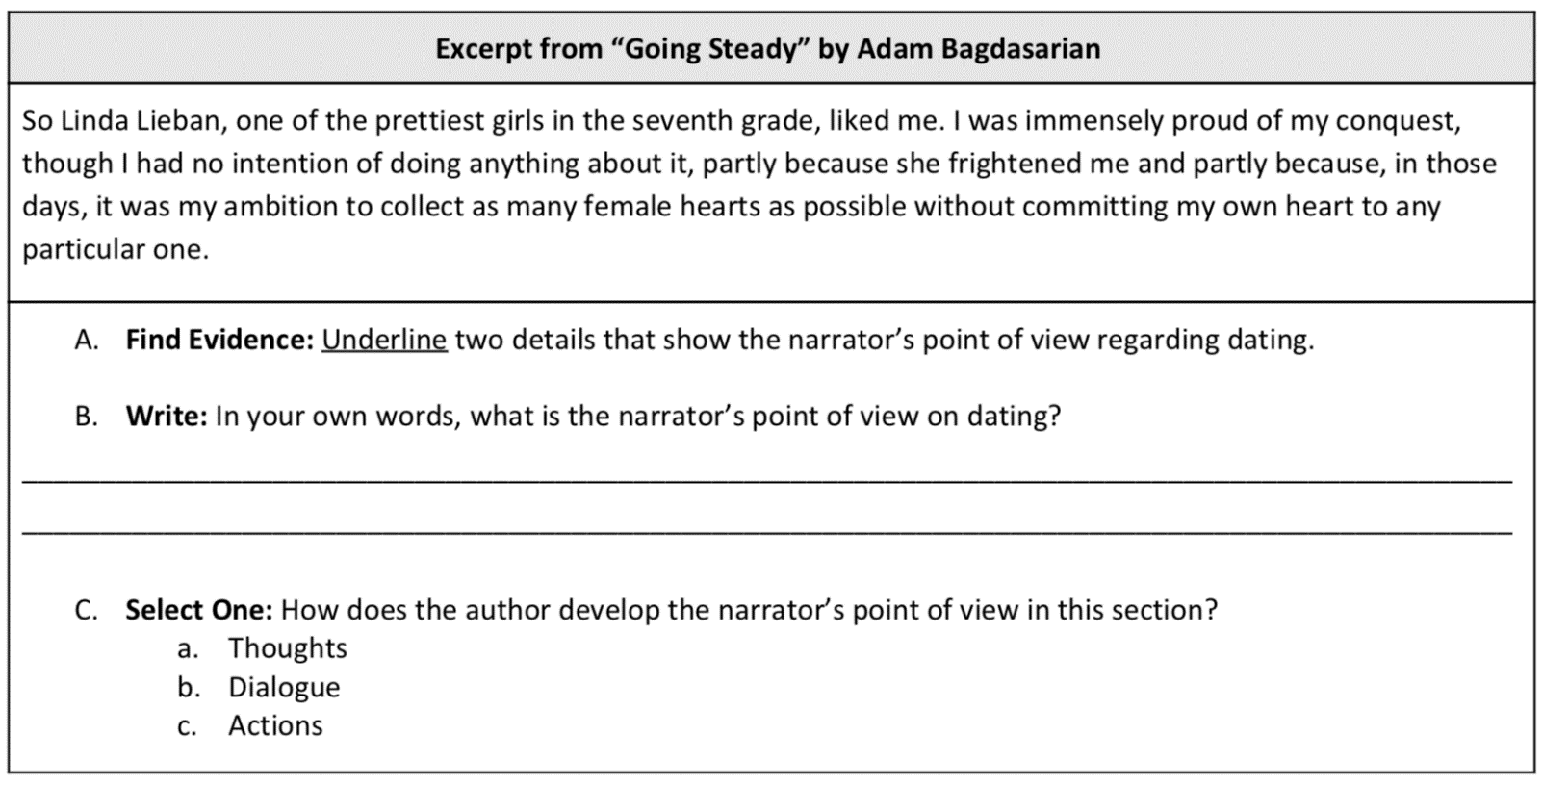
The narrator wants girls to like him but does not want a girlfriend.

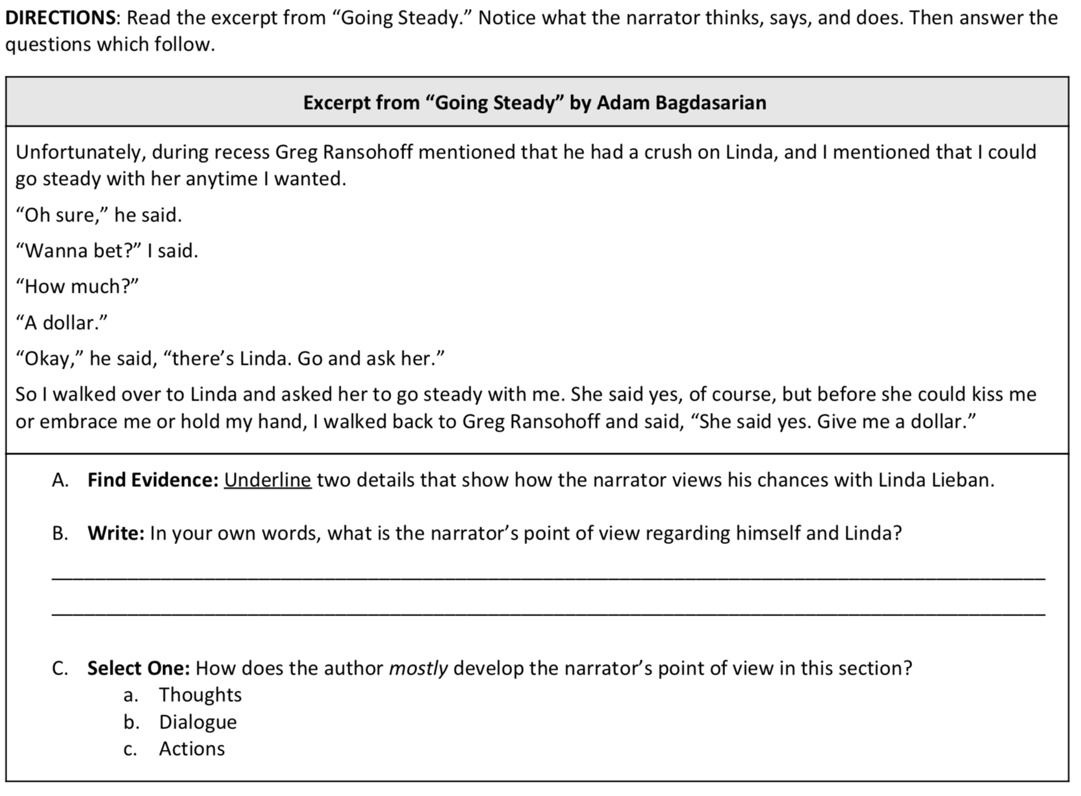
Day 2, Activity 2: Vocabulary Practice
Step 1: Fill in the blanks using the correct vocabulary word to complete each scenario. You may have to change the form of the word (ex: go, going, gone).
Step 2: Explain why the vocabulary word best fits based on context clues provided in the scenario.
Apprentices Enforced Gaped Maneuvered Manicured
Example: Every single day, Bryan wakes up at 5 o’clock in the morning to take a 10-mile jog. Then, he goes to the gym to lift weights. Afterwards, he does 20 laps in the pool. And this is before he goes to practice with the team every afternoon!
Bryan is relentless about training because he is extremely dedicated and exercises all of the time.

- Larry and Shirley were known around town as having the house with the most beautiful and expertly trimmed landscape.
Larry and Shirley had a yard because
- Throughout the summer Larry used his skills to his benefit as he moved and arranged his flowers in a way that looked professional.
Larry the flowers because
- Larry often had to put up a rope around his yard to make sure people were following the direction of his “no parking in the yard” sign when they came to visit.
The rope the sign’s message because
- After many years of taking care of just his own yard, Larry decided to start a landscaping business and hire younger people he could train in the art of landscaping.
Larry hired because
- People would drive from all over the state to view the yards that Larry’s business landscaped. They would stand and stare in amazement at the way Larry took an empty yard and made it into a work of natural art.
People at Larry’s yards because
Day 3: Active Reading
Today, we’re going to read “Sol Painting, Inc.” about a young girl who is faced with new realizations about her world. The narrator spends her summer working as a painter with her father and brother, which affects her point of view of the world. As we read, we’ll determine the characters’ points of view and examine how the author develops each perspective.

About this Text: Meg Medina is a Cuban American writer whose stories focus on how a person’s family, culture, and heritage influence them. “Sol Painting, Inc.” is from Flying Lessons & Other Stories. The main character reappears in Medina’s novel Merci Suarez Changes Gears, which earned Medina the 2019 Newberry Medal. As you read, pause to answer the questions beside the text.
Section 1
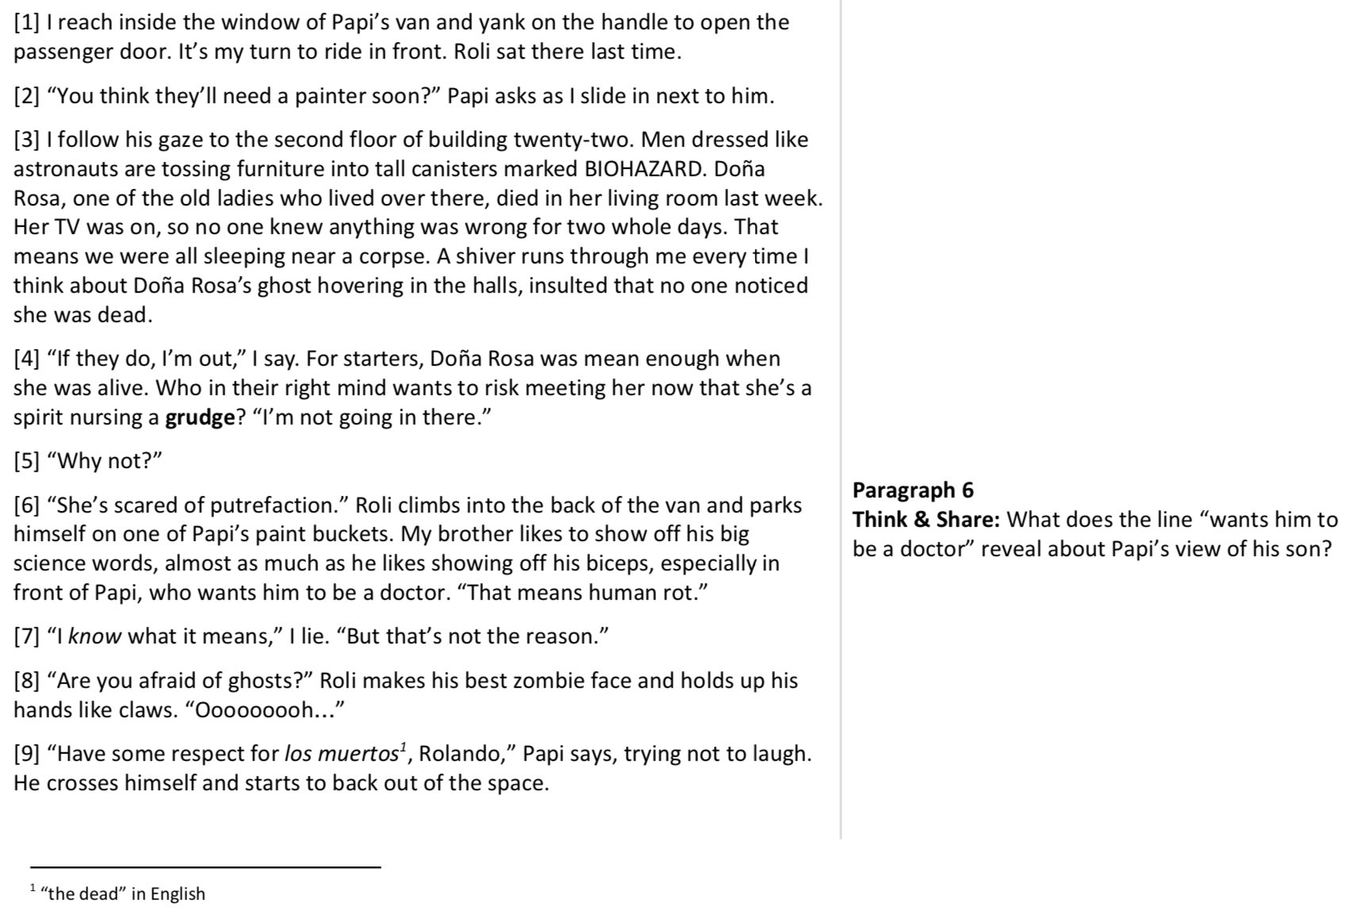
Section 2
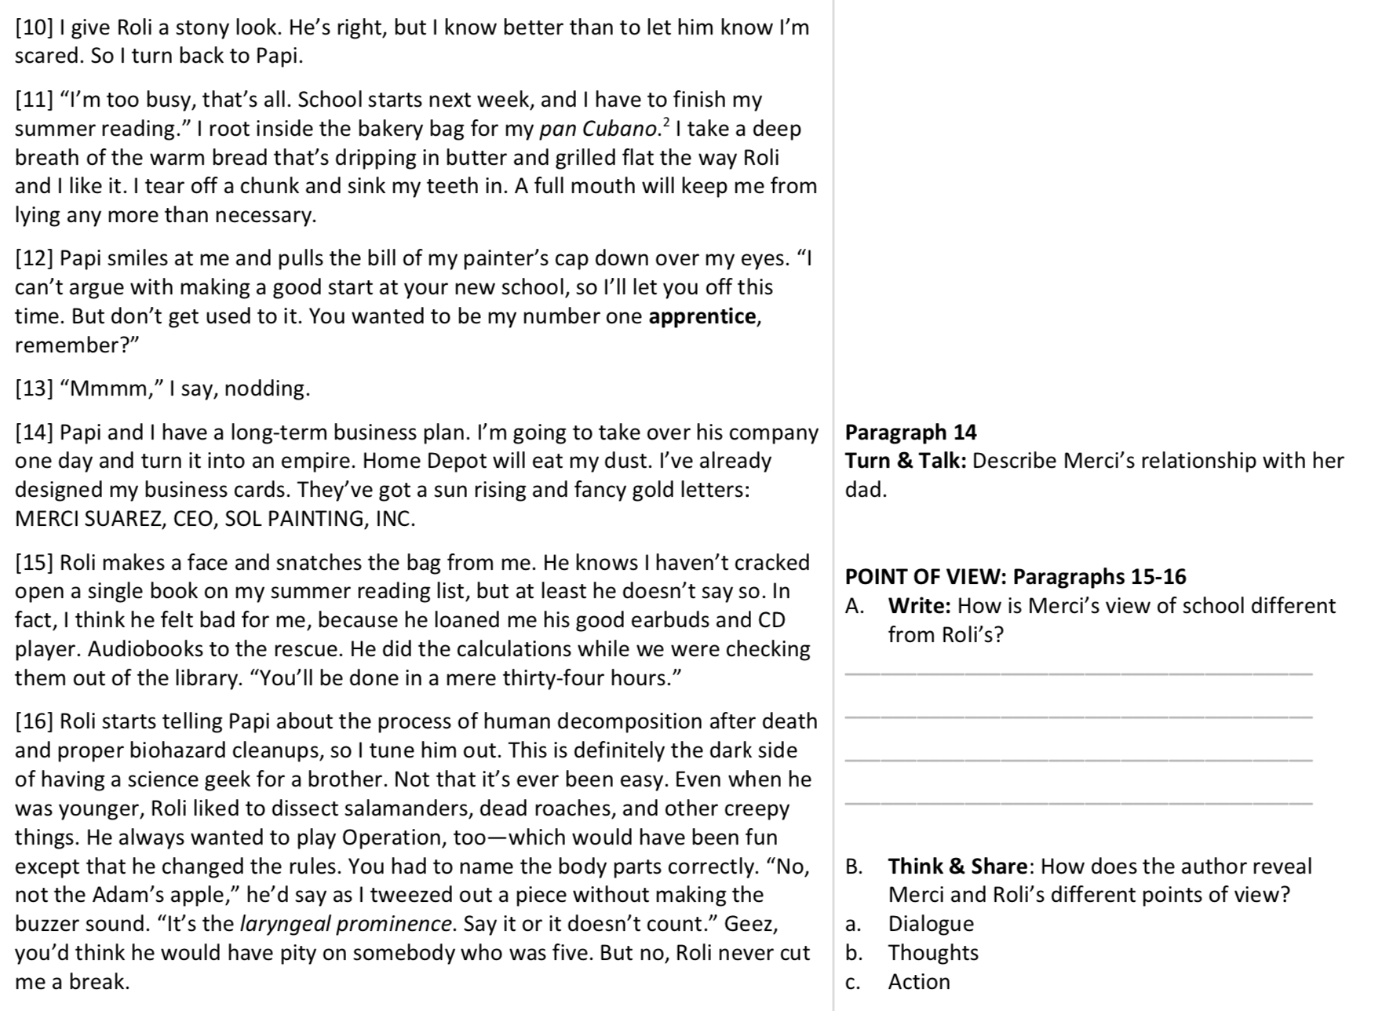
Section 3
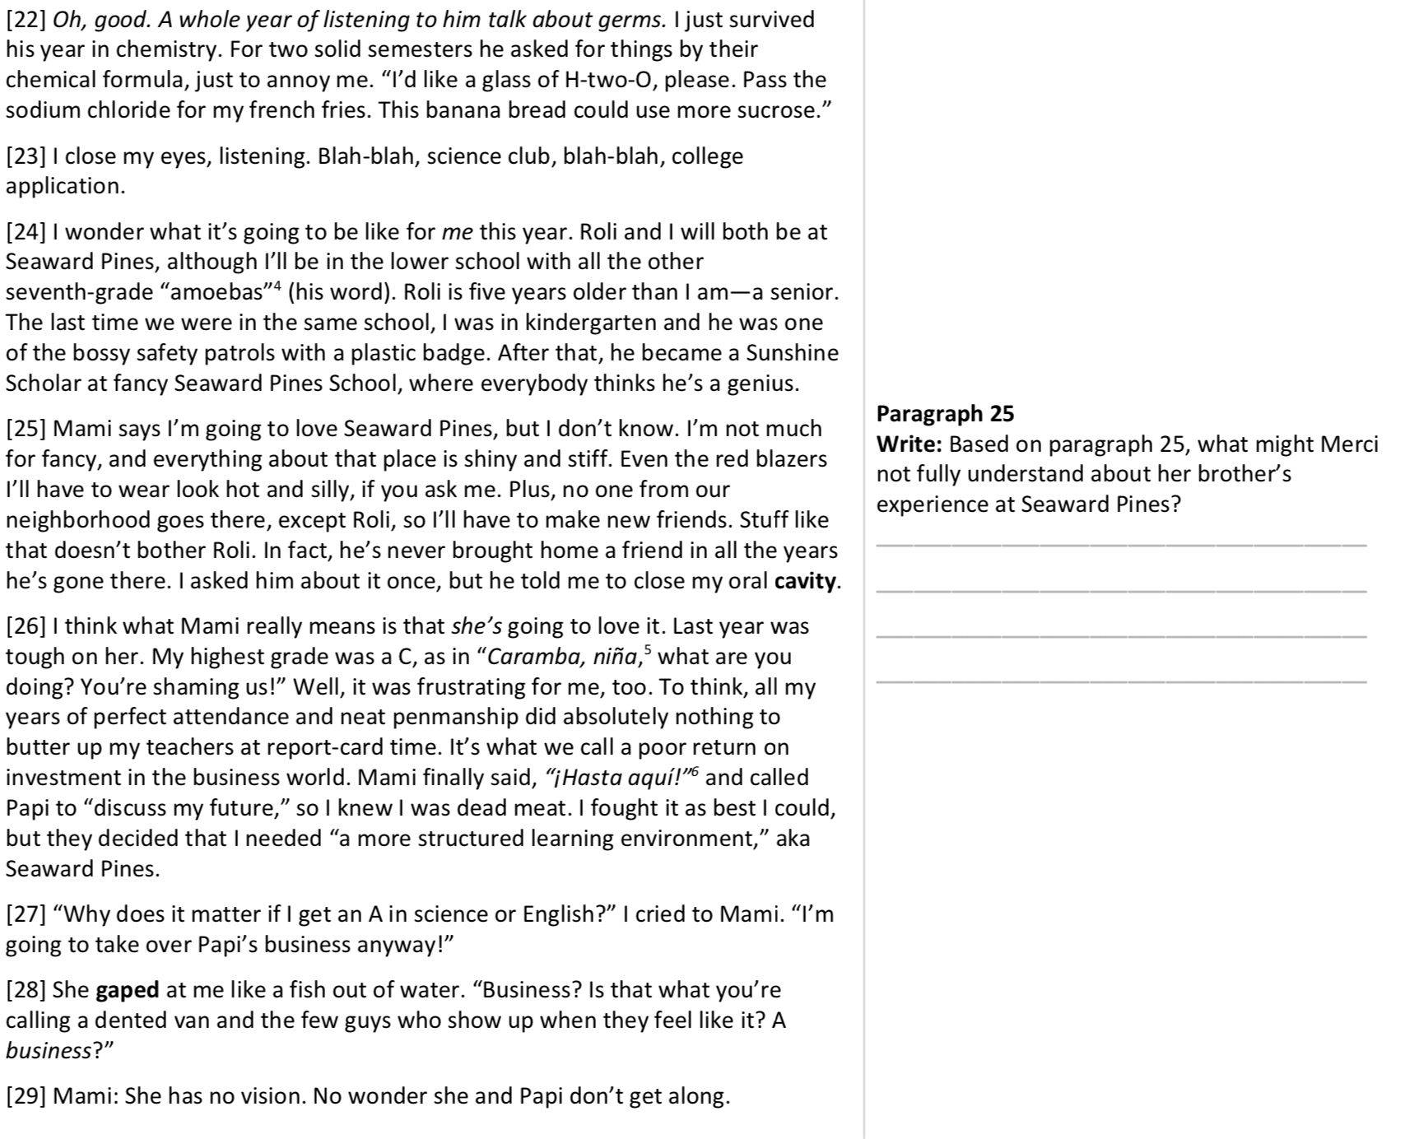
Section 4
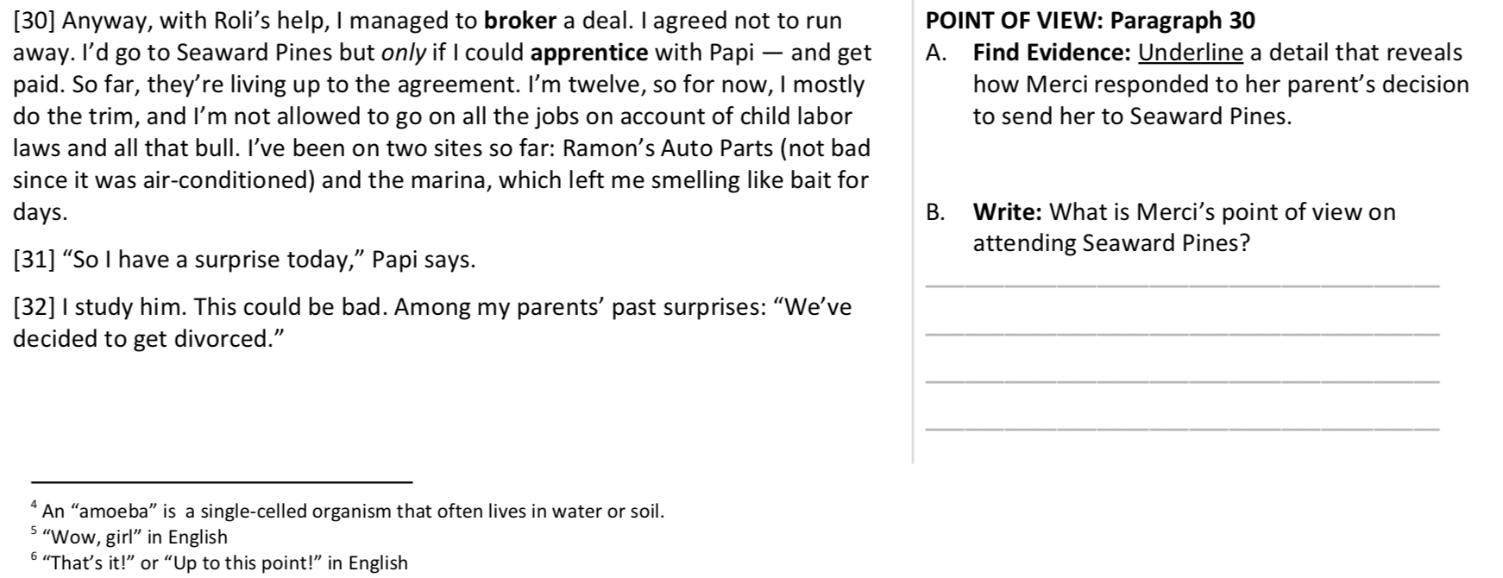
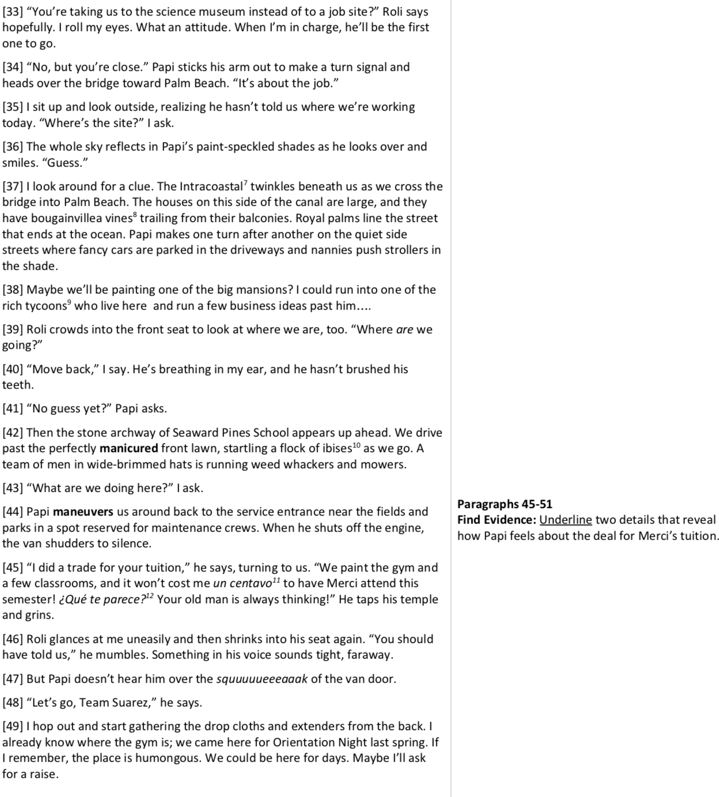
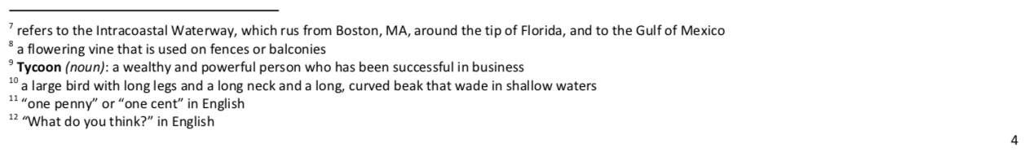
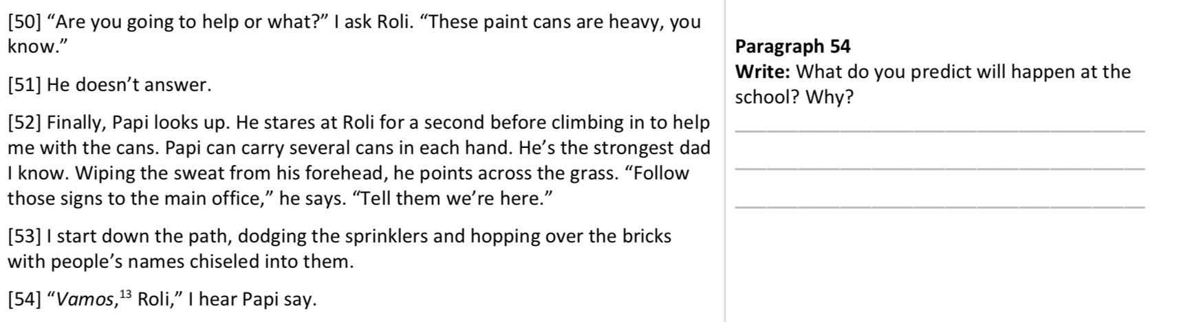
Section 5
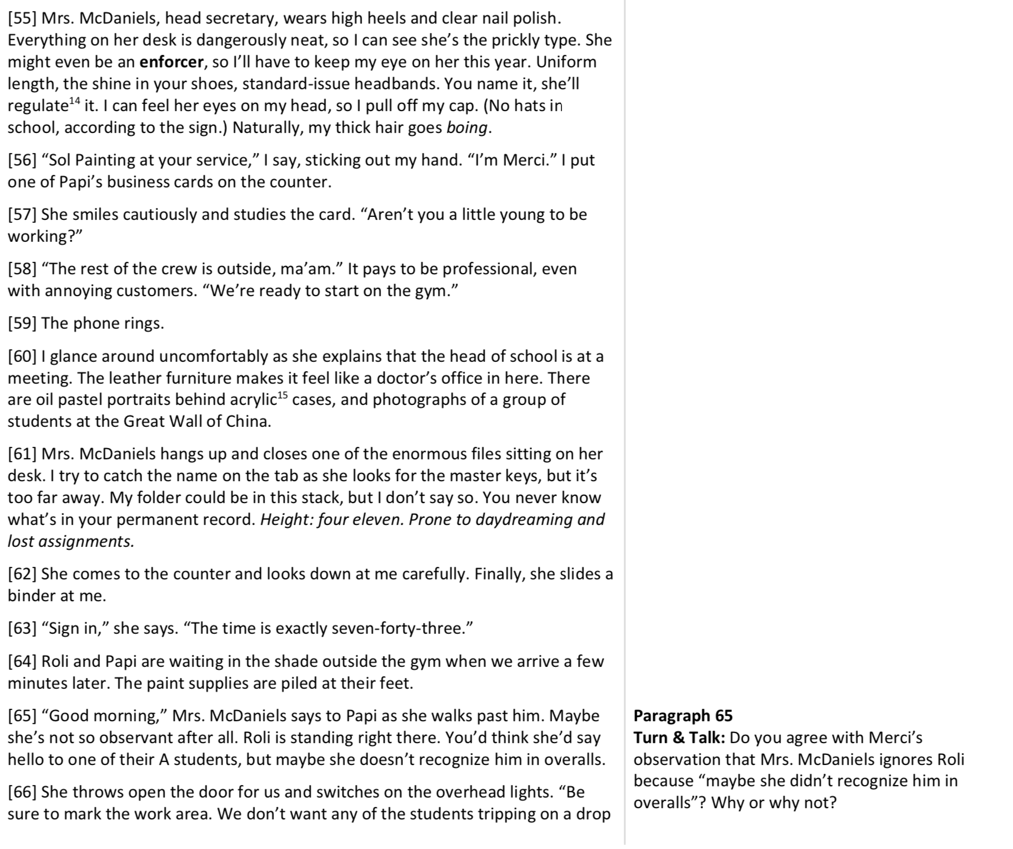
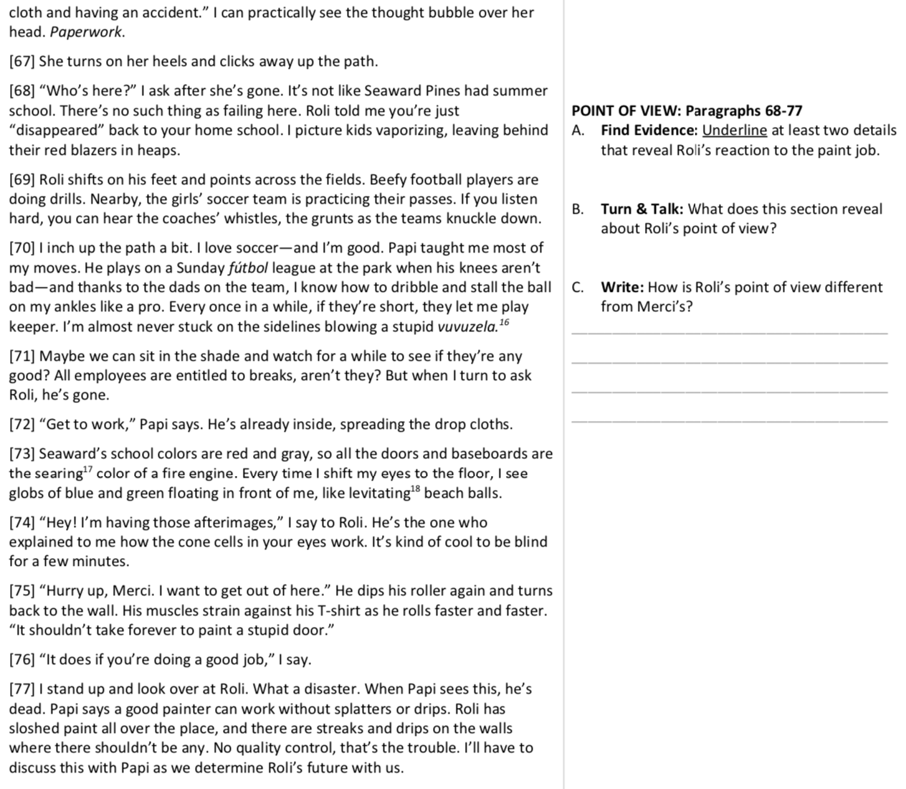
Section 6
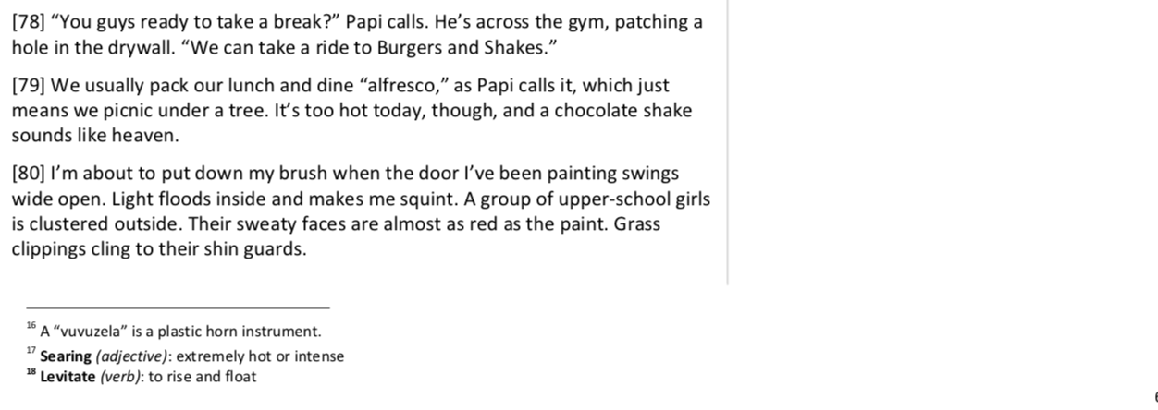
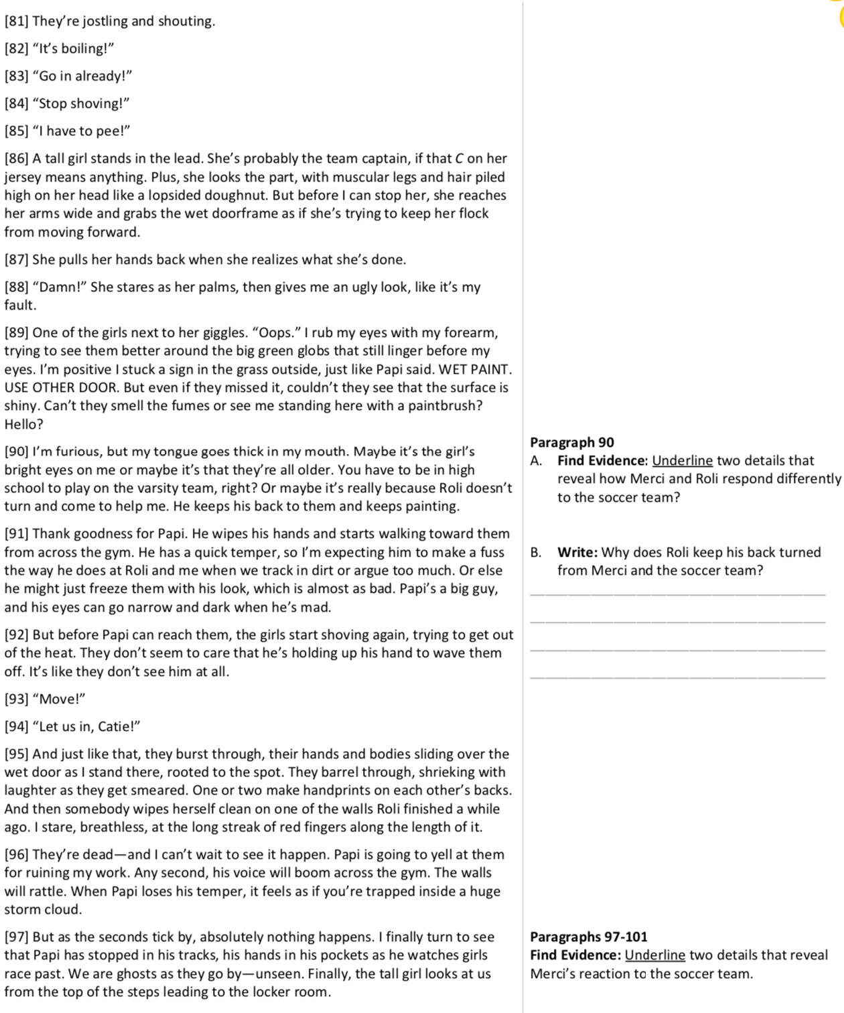
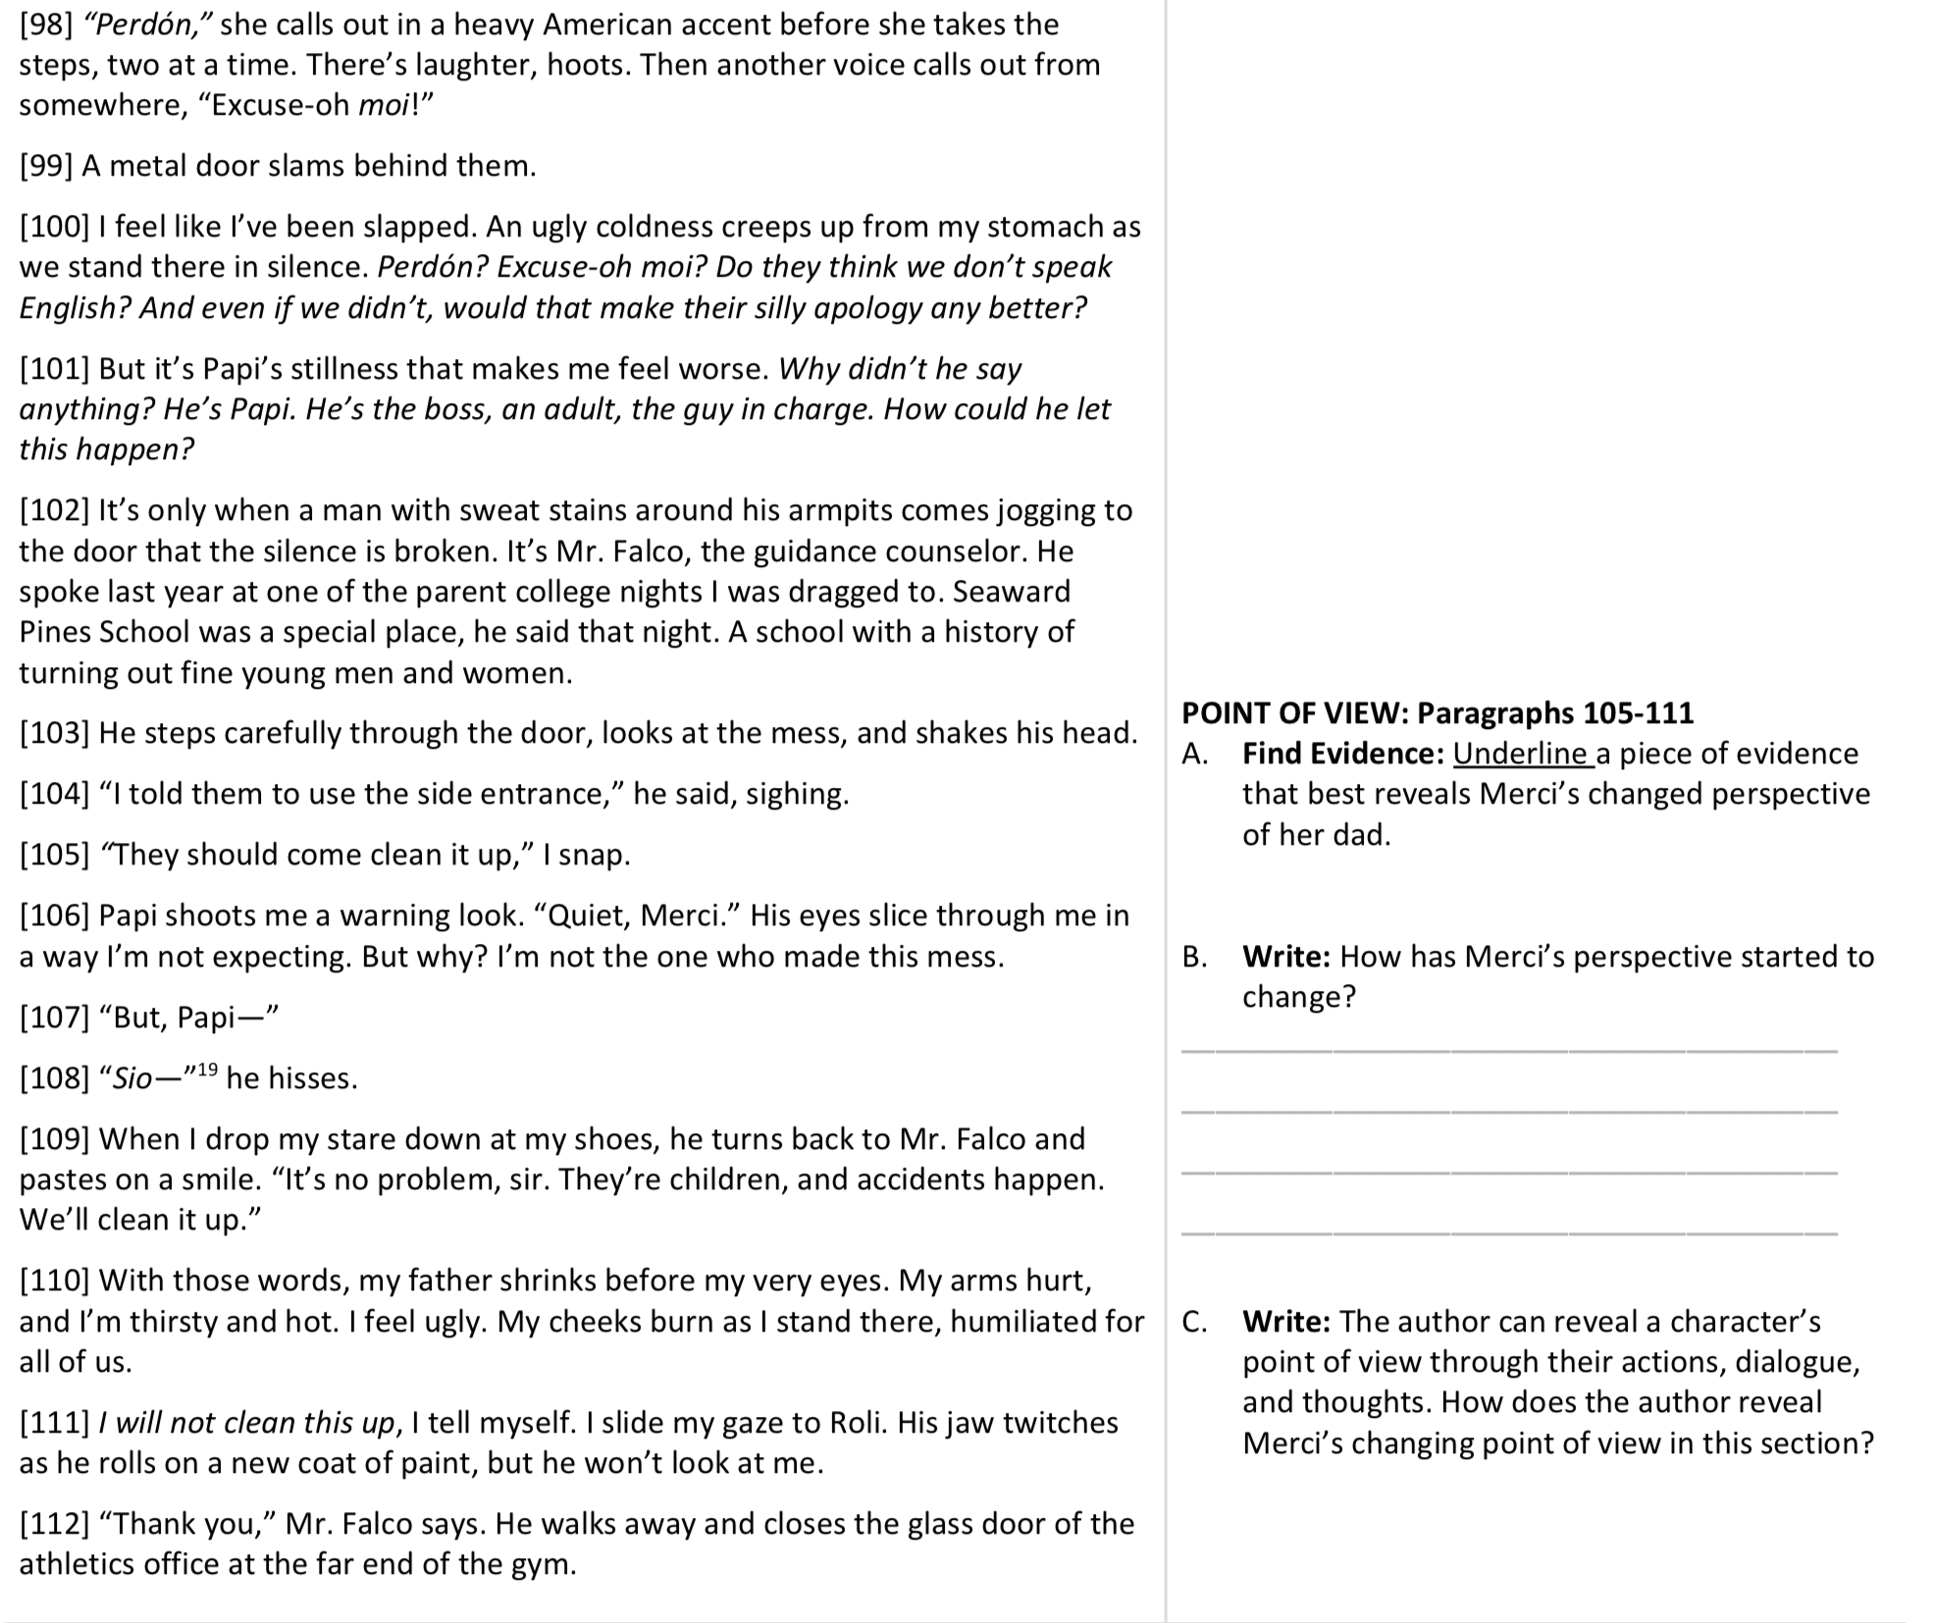
Section 7

Day 4, Activity 1: Vocabulary Application
Answer each question in 1-2 complete sentences. Make sure that you use the underlined vocabulary word in your answer.
- If you could be an apprentice for a day in any career or job, what would you choose to do? Explain why.
- What is an effective way for parents to enforce their rules and expectations with their children at home?
- Describe a scene that might cause you to stare and gape out of shock or surprise.
- Name a place where it would be difficult to maneuver a large vehicle. Why did you pick that place?
- How do people respond differently to a well-manicured space as opposed to a messy or overgrown area?

Day 4, Activity 2: Multiple Choice Questions
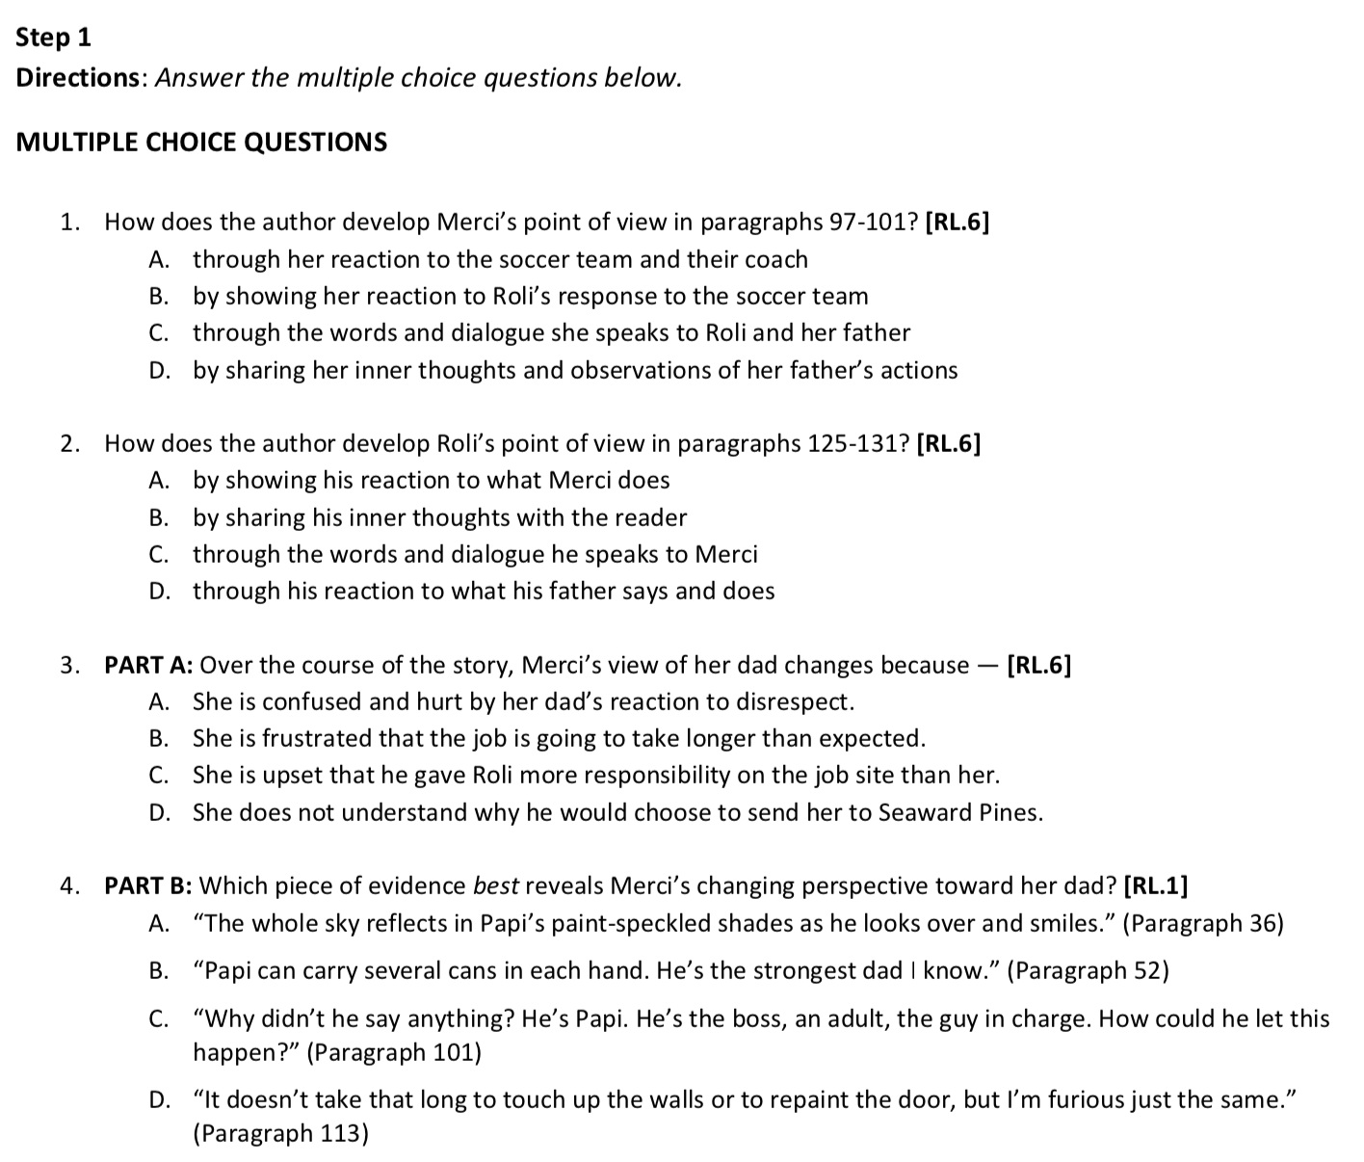

Day 5, Activity 1: Conflicting Points of View
Choose Merci and one of her family members, Roli or Papi, to creatively represent in a word and image collage using the two facing profiles. Think of images that would reflect their characteristics and points of view, and think of quotes from the story that best communicate these characteristics and points of view. Try to represent what makes them similar as well as what makes them unique. Get creative but stick to what you know from the text about their personalities.

Day 5, Activity 2: Short Response
